SOLT French Module 5 Lesson 2

Instructor Manual

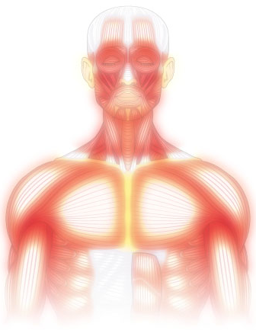

Anatomy

At the end of this lesson you will be able to talk about anatomy. To reach this objective, you will study and practice the vocabulary and grammar needed to identify the parts of the body, talk about the motor and sensorial organ functions, and identify internal and external organs.

Identify Parts of the Body

- Name main parts of the human body
- Talk about the motor and sensorial organ functions
- Identify an internal organ
- Identify an external organ

Name the main parts of the human body

Scenario: Read the conversation below as the professor asks a student about parts of the body.

Le professeur : Donne-moi quelques membres du corps qui sont liés à la fonction de marcher.
Ousmane : les jambes, les pieds, les hanches.
Le professeur : Et pour manger ?
Ousmane : les bras, la bouche, les mains, le ventre.
Le professeur : Et pour respirer ?
Ousmane : La bouche encore, les poumons, le coeur.
Le professeur : Très bien, je te remercie Ousmane.

Exerices 1 (Pair Work)

Keep the same reading partner and role-play the scenario above by improvising new words from your Vocabulary list.

Exercise 2 (Pair Work)

The class will be divided into pairs for this exercise. Study the names of the main body parts used above and in the Vocabulary. Using the illustration on the next page ask your partner the name of a body part. Follow the same procedure until each student has the chance to complete the activity.
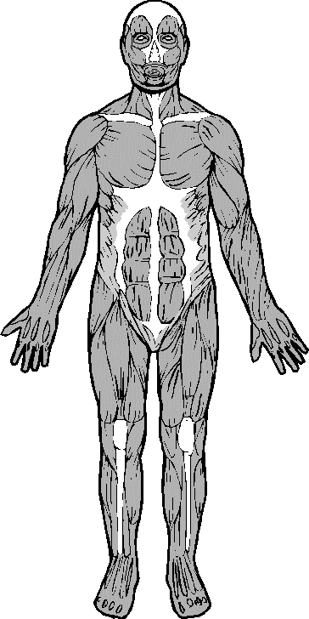
Tip of the day: Medical Emergencies

Several hospitals and clinics in Dakar can treat major and minor injuries and illnesses. There is inadequate in-patient psychiatric care, though there is very good office-based psychiatry. Public hospitals do not meet U.S. standards, but several private clinics are at the level of small European hospitals, and even approach U.S. community hospital standards. The Embassy maintains a list of physicians and other health care professionals who may see U.S. citizen patients. The Embassy does not guarantee their services or recommend any of the physicians.

Les parties du corps humain:
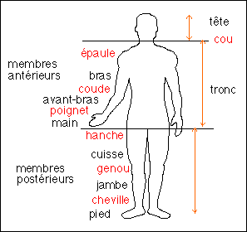
La tête
Les dents, les yeux, les oreilles, la bouche, le cerveau… Véritable tour de contrôle, notre tête contient quelques-uns des organes les plus importants de notre organisme.
Le visage → teint, yeux, front, nez, joues, lèvres, menton, cheveux
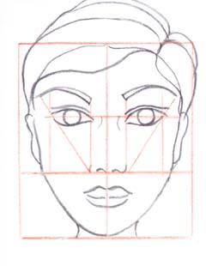
Le corps:
Le corps / La tête
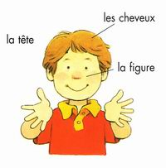 | 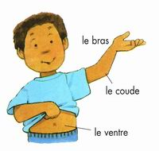 | 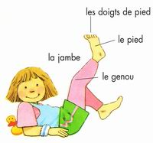

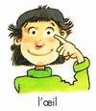 | 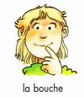 | 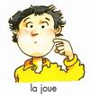
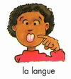 | 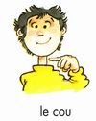 | 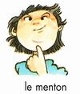
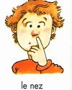 | 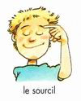 | 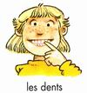
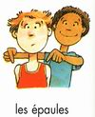 | 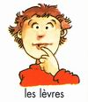 | 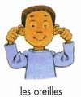
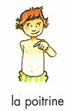 | 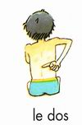 | 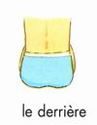
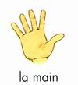 | 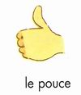 | 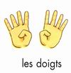

Exercise 2 (Class Work)

Which body parts need to be trained to engage in the following activities?

1. Jouer au foot ______________________________
2. Danser ______________________________
3. Faire de la planche à voile ______________________________
4. Chanter ______________________________
5. Sauter ______________________________
6. Nettoyer ______________________________

Exercise 3 (Pair Exercise)

Write down the body part that is connected to the neighboring body parts.

1. doigt _______________________
2. nez _______________________
3. langue _______________________
4. genou _______________________
5. cou _______________________
6. pouce _______________________
7. dos _______________________
8. oreille _______________________
The following image and chart gives you key vocabulary for different facial features in Wolof. Study the image and words below. Share your ideas with the class about the language similarities and differences.
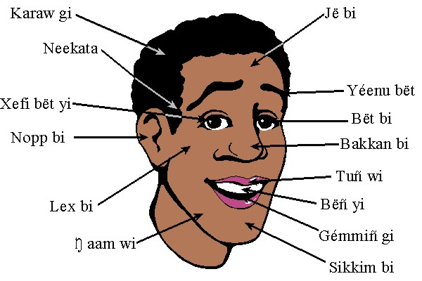
Wolof | English | French
kanam gi/xar- kanam gi  cëlmaay li | face, facial appearance, expression | le visage, physionomie
jë bi | forehead | le front
neekata bi | temple | la tempe
nàmptal bi/naqtal bi | fontanelle | la fontanelle
lex bi | cheek | la joue
legg wi | most protuberant point of cheek below the eye | partie la plus saillante de la joue, au-dessous de l'oeil.
karaw gi/ kawar gi | hair, body hair | les cheveux, le poil
kaabaab gi | place of sideburns & along jaw | la joue des temporaux au menton
faas yi | sideburns | les favoris
kaaŋ mi | skull | le crâne, boîte crânienne humaine
sikkim bi | chin; beard | le menton; la barbe
ŋaam wi | jaw | la mâchoire
yaxu ŋaam bi | jawbone | la mâchoire
Exercise 1

Match the letters with the words for the parts of the body.
a
n
c
b
f
j
s
i
h
k
l
u
o
p
m
d
e
q

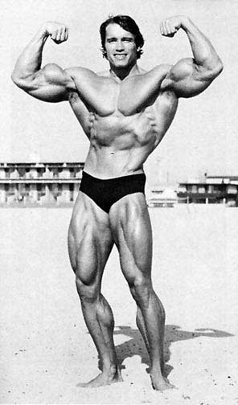

k | genou | j | bras | u | doigt | h | poitrine | d | main
f | bouche | a | front | b | oeil | s | dos | o | cou
q | épaule | m | orteil | c | nez | n | tête
e | jambe | l | pied | p | oreille | i | ventre

Exercise 2 (Class Work)

Give the proper arrangement for the parts of the body from the top to the bottom. Use numbers 1 (top) - 12 (bottom). Be prepared to demonstrate to the class. For example, numéro 1, c’est le front, etc.

Cou 5  Ventre 8  Pied 10  Bras 6 | Front 1  Nez 3  Bouche 4 | Main 7  Jambe 9  Oeil 2

Les organes internes:
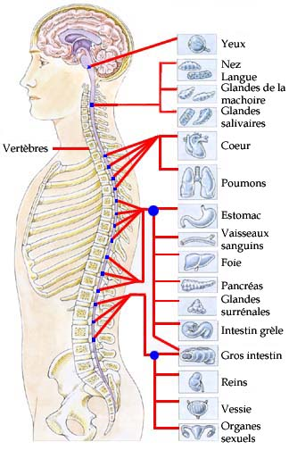

LE CORPS HUMAIN

In order to conduct the following exercises refer to the anatomy figure below for the names of the interior organs in French.
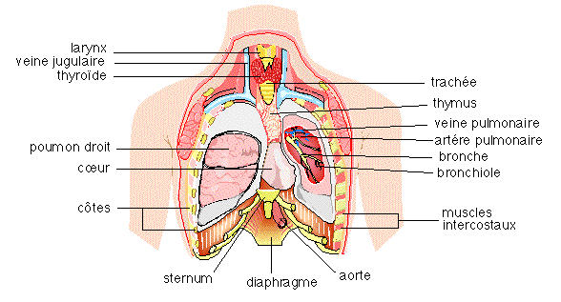

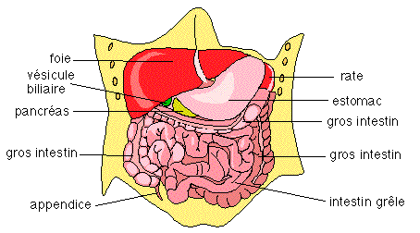

Exercise 3 (Class Work)

Fill in the blanks with the correct organs and then share your answers with the class.

- L'estomac digère la nourriture.
- Quand on fume, on risque d'avoir un cancer des poumons.
- Quand l'appendice est infecté, on doit se faire opérer pour le faire enlever.
- Le coeur pompe le sang dans le corps.
- Les reins purifient le sang et permettent l’élimination de l’eau.
- Le foie fabrique un litre de bile par jour stockée dans la vésicule biliaire.
- La vessie est un réservoir dans lequel s’accumule l’urine.
- Le foie sécrète la bile qui élimine les toxines et le cholestérol .
- Les intestins sont un tube digestif entre l’estomac et l’anus.

Exercise 4 (Pair Exercise)

Interview each other, first, about what parts of the body you do or don’t like, and, second, about which parts of your body have been trained well and which ones have not. Give explanations for both sections of this activity.

S’asseoir sur un banc. Être assis (e) ...

s’asseoir
je m'assieds  tu t'assieds  il s'assied  nous nous asseyons  vous vous asseyez  ils s'asseyent | je m'assiérai
 | que je m'asseye

Je m’assieds sur un banc.
Il s'est assis sur sa jambe en regardant la télé et maintenant il a des fourmis dans le pied.

There are a few irregular verbs that have an irregular stem but use the regular -ir/-re endings.
s’asseoir | → s'ass-
Remember that with reflexive verbs like to sit down; the pronoun is placed after the verb in the command form.

Examples:
Assieds-toi !
Asseyons-nous !
Asseyez-vous !

Parts of the body + pronominal verbs: Remember with parts of the body; use a verb such as se laver, se casser, etc. rather than a possessive adjective like, My hair, eyes, feet, and so on.

Example: Il se lave les cheveux.
Appendice (n.m)  S’asseoir (verb)  Banc (n.m)  Bouche (n.f)  Bras (n.m)  Coaguler (verb)  Coeur (n.m)  Corps (n.m)  Cou (n.m)  Coude (n.m)  Coup de poing (n.m)  Cuisse (n.f)  Dent (n.f)  Dentiste (n.m)  Doigt (n.m)  Dos (n.m)  Envoyer (verb)  Épaule (n.f)  Estomac (n.m)  Foie (n.m)  Front (n.m)  Genou (n.m)  Gorge (n.f)  Gueule (n.f)  Intestin (n.m)  Jambe (n.f)  Langue (n.f)  Main (n.f)  Nettoyer (verb)  Nez (n.m)  Oeil (n.m. sing) Yeux (plural)  Oreille (n.f)  Orteil (n.m)  Paume (n.f)  Pied (n.m)  Poitrine (n.f)  Poumon (n.m)  Rein (n.m)  Repousser (verb)  Sang (n.m)  Tête (n.m)  Tout à coup (adv.)  Ventre (n.m)  Vessie (n.f) | Appendix  To sit  Bench  Mouth  Arm  To clot  Heart  Body  Neck  Elbow  Fist blow  Thigh  Tooth  Dentist  Finger  Back  To send  Shoulder  Stomach  Liver  Forehead  Knee  Throat  Mouth (vulgar)/ animal’s mouth  Intestine  Leg  Tongue  Hand  To clean  Nose  Eye  Ear  Toe, big toe  Palm (hand)  Foot  Chest  Lung  Kidney  To push back  Blood  Head  All of a sudden, suddenly  Belly, stomach  Bladder

Parts of the body: danse and culture

The one unifying aesthetic of African dance is an emphasis upon rhythm, which may be expressed by many different parts of the body or extended outside the body to rattles or costumes. African dances may combine movements of any parts of the body, from the eyes to the toes, and the focus on a certain part of the body might have a particular social significance.

Africans often judge the mastery of a dancer by the dancer's skill in representing rhythm. More skillful dancers might express several different rhythms at the same time, for example by maintaining a separate rhythmic movement with each of several different parts of the body. Rhythm frequently forms a dialogue between dancers, musicians, and audience.

One of the most remarkable aspects of African dance is its use of the movements of daily life. By raising ordinary gestures to the level of art, these dances show the grace and rhythm of daily activities, from walking to pounding grain to chewing. In the Côte d'Ivoire dance known as ziglibit, stamping feet reproduce the rhythm of the pounding of corn into meal. During the thie bou bien dance of Senegal dancers move their right arms as if they were eating the food that gives the dance its name.

The Fulani acrobats of Senegal, the Gambia, and Guinea perform movements similar to those of American break dancing, such as backspins, head and handstands.
African dance moves all parts of the body, in contrast to many European forms that rely mostly on arm and leg movement. Angular bending of arms, legs and torso; shoulder and hip movement; scuffing, stamping, and hopping steps; asymmetrical use of the body; and fluid movement are all part of African dance.

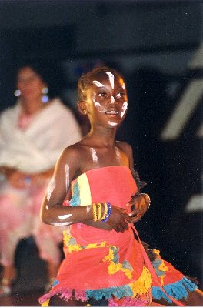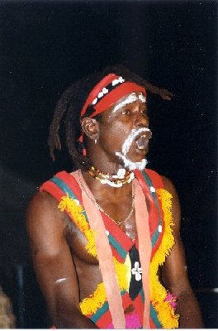
Activity 1

Take turns describing the physical appearance of your classmates without mentioning their names. Your partner has to be able to guess the name of the person you are describing or be able to point out the person.

Activity 2

Pair activity. Emulate Picasso. Alternate drawing various parts of the body. After you draw a part, fold the paper a little just so your partner can't see your drawing. Check out the part you've drawn (you don't have to follow the order in which they are listed). Once all the parts have been drawn, unfold the paper and check out your masterpiece! Then show it to the rest of the class, and vote for the most eccentric one.

Here are the parts to be drawn:

une tête  2 yeux  une bouche  un cou | un nez  2 bras  2 mains  un ventre | 2 jambes  2 oreilles  2 pieds

Activity 3

Read the following idiomatic expressions that contain parts of the body and check whether their English equivalent uses the same part of the body.

1. Avoir les yeux plus gros que le ventre.
2. Donner sa langue au chat.
3. Prendre ses jambes à son cou.
4. Tenir la jambe à quelqu'un pendant des heures.
5. Coûter les yeux de la tête.
6. Faire quelque chose les doigts dans le nez.

1. To have one’s eyes bigger than one’s stomach.
2. To give in.
3. To take to one’s heels.
4. To keep someone hanging about.
5. To cost an arm and a leg.
6. To do something standing on one’s head.

Activity 4

Your instructor will give you sentences and you have to guess which part of the body or organ they relate to. Make sure to include the correct definite article. Write down any clues such as a verb form (to see, to hear, etc.) to share with the class.

Script:
1. On en a besoin pour voir. Les yeux
2. On s’en sert pour mâcher. Les dents
3. On en a besoin pour écouter. Les oreilles
4. C’est l’organe qui nous permet de respirer. Le nez
5. On s’en sert pour courir. Les jambes
6. On l’utilise pour écrire. La main
7. C’est l’organe qui digère les aliments. L’intestin
8. C’est l’organe qui pompe le sang dans les veines. Le cœur

Activity 1

Class activity. Take turns in giving commands to the student to their right that involve parts of the body for him to execute. Example: fermez les yeux, ouvrez la bouche, levez le pied gauche…If the student does not execute the proper gesture, he is out. The last student wins.

Activity 2

Pair activity. You are a prospective organ donor. Which organ(s) do you plan to donate? Tell your partner who will write an organ donor's card for you.

Activity 3

Class activity. Listen to a children's song, and point to the parts of the body as they are mentioned. This song adds a part of the body with each couplet. Here are the lyrics:

Refrain: Alouette, gentille alouette, Lark, sweet lark, .
Alouette, je te plumerai. Lark, I’ll pluck you

Je te plumerai la tête I’ll pluck your head
Je te plumerai la tête I’ll pluck your head

Et la tête, alouette, ah! And the head, lark, ah!

Refrain Refrain

Je te plumerai les yeux I’ll pluck your eyes.
Je te plumerai les yeux. I’ll pluck your eyes.
Et les yeux, et la tête, ah! And the eyes, and the head, ah!

Refrain. Refrain

Etc.

Activity 1 Track 64

CD. Listen and fill in the blanks with the appropriate parts of the body.

1. Les dents se trouvent dans la bouche.
2. Ne fumez pas quand vous avez mal à la gorge.
3. Au milieu du visage il y a le nez.
4. Je dois aller chez le dentiste pour me faire nettoyer les dents.
5. Entre le bras et le cou, il y a l'épaule.

Activity 2

Select the correct description of each of these pictures
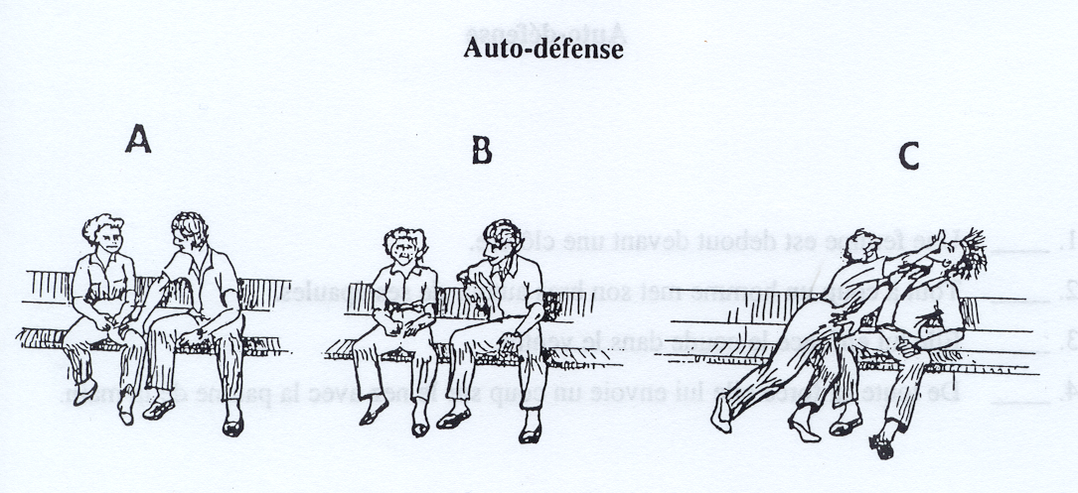

1. Un homme s’assied à côté d’elle et lui touche la cuisse.
2. Elle lui envoie un coup sur le nez avec la paume de la main.
3. Une femme est assise sur un banc.
4. Elle lui envoie un coup de poing dans la gueule.
5. Elle le repousse du genou.
6. Elle lui marche sur le pied et il tombe par terre.

Activity 3

Be ready to conduct an exercise session for the class by giving commands and explaining the body movements to be done.

Activity 4

Select the correct description of each of these pictures.

1. Une femme est debout devant une clôture.
2. Tout à coup un homme met son bras autour de son épaule.
3. Elle lui enfonce le coude dans le ventre.
4. De toute sa force, elle lui envoie un coup sur le nez avec la paume de la main.

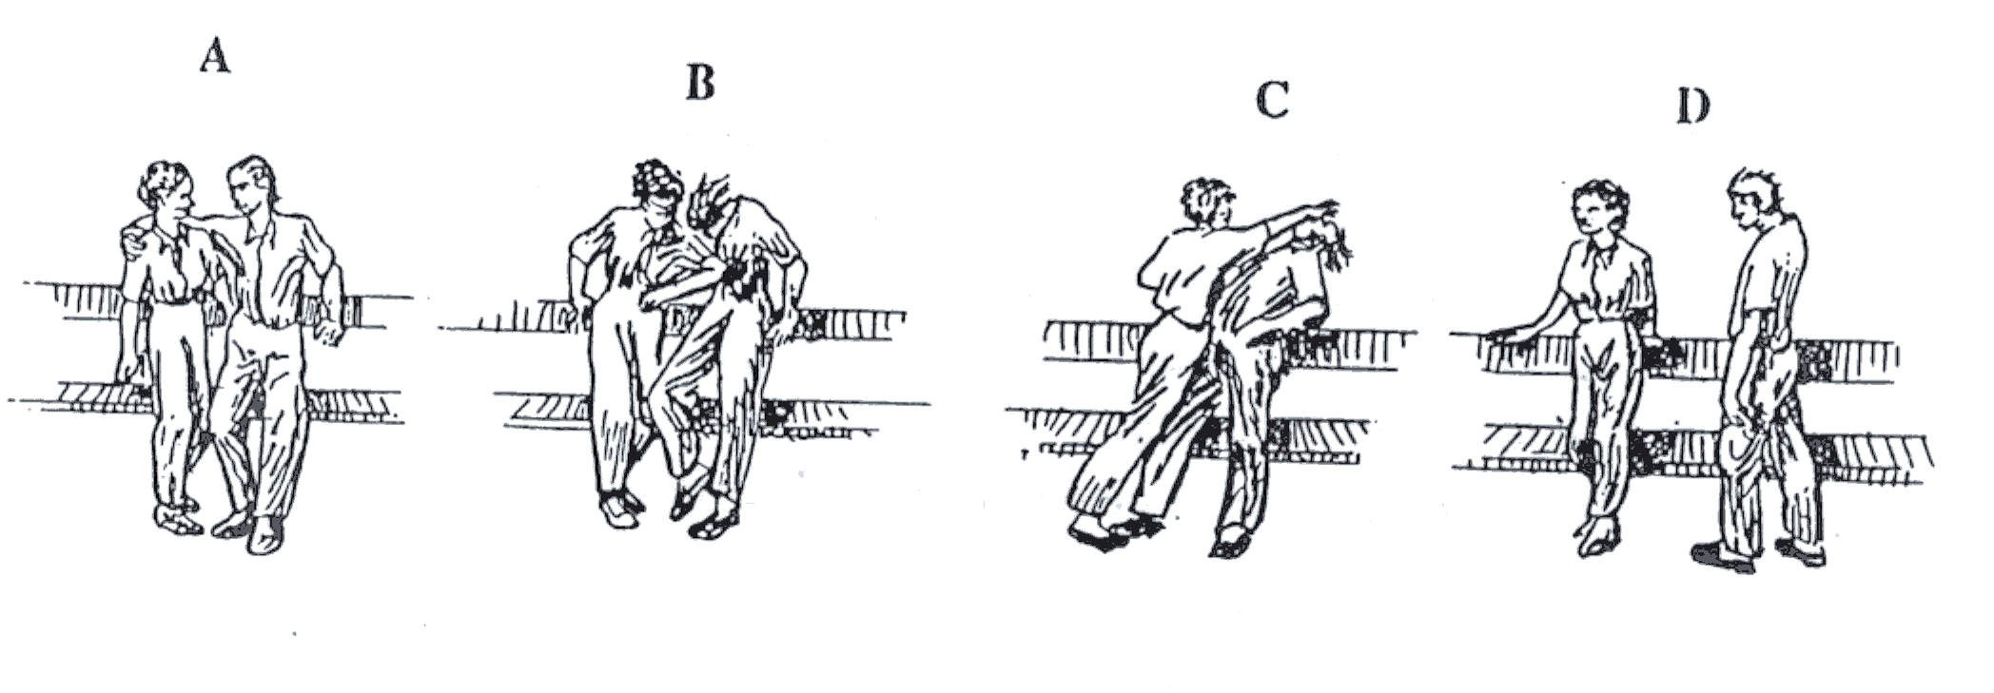
Activity 5

Identify the parts of a human face (or head) in French:
1) All parts that are visible in this photo.
2) Which parts are (partially) hidden?

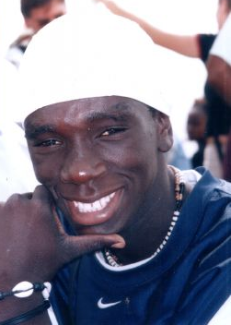
Bira~un grand maître du tambour

