SOLT Serbian Module 5 Lesson 4

Medical Emergencies

Medical Emergencies Serbian SOLT 1
Objectives Module 5 Lesson 4

During this lesson, the students will learn about medical emergencies. Under this Terminal Learning Objective, the students will learn two tasks: discussing medical emergencies, discussing his/her injury. At the end of the lesson, the students will be able to:

- Discuss medical emergencies. This task will include:

- Call for assistance
- Report an accident
- Discuss the scene of an accident
- Interpret in emergency situations

- Discuss his/her injury. This task will include:

- Make a doctor’s appointment
- Discuss medical treatment
- Request for medication at the doctor’s office
- Discuss diet for good health
- Ask about the state of an illness and recovery from an illness
- Respond to the state of an illness and recovery from an illness

Medical Emergencies Serbian SOLT 1
Introduction Module 5 Lesson 4

The traffic rules are not the same in every country and not having the basic knowledge of them could cause serious problems for someone living or just visiting the foreign country. An American pedestrian, for example, would expect to have the right of way on a street that has a pedestrian crossing. In the FRY, however, pedestrian crossing lines are often ignored and the drivers themselves make rules for the pedestrians. Sometimes motorists run the red light and that’s why one needs to be very cautious when crossing a street.

Tip of the day
Самарићанин is a Serbian term for the English a good Samaritan.

Exercise 1
Vlado has just witnessed an accident on the road. He grabs for his cellular phone and phones 911. Read his conversation with a 911 operator and answer the questions.

Добри Самарићанин

А. Хитна помоћ Београд. Изволите. emergency squad
Владо: Добро вече. Молим вас пошаљите кола
хитне помоћи. Догодила се тешка саобраћајна несрећа.
А. Како се зовете и одакле зовете?
Владо: Владо Мирковић. Зовем са Ибарске магистрале,
oтприлике 20 километара од Београда.
А. Да ли знате има ли повређених?
Владо: Мислим да је двоје повређено, али нисам сигуран. two
А. У реду. Кола хитне помоћи су већ кренула у том правцу.

    - У које доба дана се догодила несрећа?
    - Где се несрећа догодила?
    - Колико људи је повређено?

Answers: 1. Увече 2. Догодила се на Ибарској магистрали. 3. Повређено је двоје људи.

Medical Emergencies Serbian SOLT 1
Introduction Module 5 Lesson 4

Exercise 2
Using the previous exercise as a model, make up a dialogue with a partner. Call for assistance (your partner) and report an accident.

Exercise 3
The police arrived and they are talking to Vlado. Read this dialogue and fill in the missing parts in the statements that follow.

Милициoнер: Ви сте очевидац. Видели сте шта eyewitness
се догодило?
Владо: Тачно.
Милиционер: Да ли можете описати несрећу? describe
Владо: Возач Ладе је покушао претећи Заставу и сударио to pass, to collide
се са Мерцедесом.
Милиционер: Мерцедес је долазио из супротног правца? opposite direction
Владо: Тако је.
Милиционер: Хвала. Причекајте овде. Можда ћемо
имати још неко питање за вас.
Владо: Нема проблема.

- The policeman is asking Vlado to describe the ________________.
- Lada was _____________ Zastava.
- Mercedes collided with _______________.
- The policeman wants Vlado to __________ for some other questions.

Answers: 1. accident 2. passing 3. Lada 4. wait

Medical Emergencies Serbian SOLT 1
Introduction Module 5 Lesson 4

Tip of the day
Шљива испод ока is a colloquial Serbian term for the English black eye. Модрица испод ока has the same meaning and it is a regular term for this description.

Exercise 4
Nada wants to make a doctor’s appointment. Listen to her phone conversation with a clerk at the doctor’s office and decide if the statements are true or false.

Instructor’s reading:
А. Ординација доктора Поповића. Изволите.
Нада: Добар дан. Хтела бих да закажем код
доктора Поповића.
А. Када желите да дођете?
Нада: Да ли може данас?
А. Може између 4 и 5.
Нада: Одлично.
А. Како се зовете?
Нада: Нада Симић.
А. Да ли сте осигурани?
Нада: Јесам.
А. Онда се видимо у 4. Довиђења.
Нада: Довиђења.

T F

1. Nada wants to see her doctor tomorrow. _____ _____

2. She insists to come at 5 o’clock. _____ _____

3. The appointment is scheduled between 4 and 5. _____ _____

4. Nada doesn’t have insurance. _____ _____

Answers: 1. F 2. F 3. T 4. F

Medical Emergencies Serbian SOLT 1
Introduction Module 5 Lesson 4

Exercise 5
Look at the image below and read the recommendations given to Nada by her doctor. Answer the questions that follow.

Пирамида здраве хране

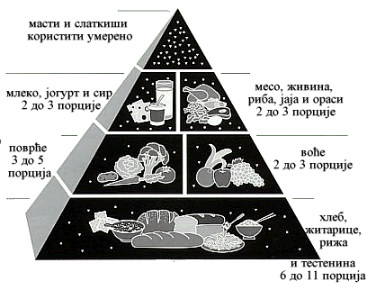
1. Имате вишак килограма. Требате да смршате 15 килограма.
2. Немојте да једете масну и калоричну храну
3. Избегавајте слаткише
4. Једите доста воћа и поврћа
5. Прекините пушити

1. According to the image, what kind of health problem does Nada have?
2. Is she overweight or underweight?
3. What is the first advice Nada gets from the doctor?
4. Name the three most important things that are mentioned in the doctor’s
recommendation?

Answers: 1. She has eating problems. 2. She is overweight. 3. He recommends to her to loose 15 kilograms. 4. Stop smoking, don’t eat food rich on fat and calories, eat plenty of vegetables and fruits.

Medical Emergencies Serbian SOLT 1
Introduction Module 5 Lesson 4

Exercise 6
Assume the role of a doctor. Your patient (your partner) has eating problems. First, ask him/her about his/her eating habits. Give him/her advice for good health. You can use the previous exercise as a model.

Medical Emergencies Serbian SOLT 1
Grammar Notes Module 5 Lesson 4

Collective Numerals: двоје, троје, четвoро... (two, three, four…)

Read the following examples:

Examples:
Двоје људи је повређено. Two people are injured.
Имала је седморо деце. She had seven children

The underlined words in the sentences above are called collective numerals. Collective numerals in Serbian have singular and plural. Singular collective numerals, except for двоје (two), обоје (both), троје (three), четворо (four), are formed by adding the ending – ро to the neuter form of ordinal numbers.

пето (fifth-neuter form) + ро = петоро
шесто (sixth-neuter form) + ро = шесторо etc.

Except for the nominative, accusative and vocative case, all other cases are seldom used. Collective numerals have the same endings in all these three cases.

Usage: When to use collective numerals?

Collective numerals are used for counting groups of mixed humans (men, children, women), or mixed animals.

If one wants to say that he has five children of different genders, one would say in Serbian:

Имам петоро деце.

If one wants to say that he has five daughters or five sons, one would not use collective numerals. One would use cardinal numbers.

Имам пет кћерки. or Имам пет синова.

*Note: The verbs used with collective numerals are always in neuter singular.

Двоје студената долази данас на предавања.
(Two students are coming to the seminar today.)

Medical Emergencies Serbian SOLT 1
Grammar Notes Module 5 Lesson 4

Collective Numerals (continued)

Please note that while the previous mentioned collective numerals express or indicate a group of two, three or more, the forms двојица, тројица, четворица, etc. are used only to count male humans. The verbs used are in plural. See the example:

Четворица мушкараца су била у групи.
(Four men were in the group.)

Exercise 1
Work in pairs. Ask each other the questions written below and provide the answers using the collective numerals in the parenthesis.

1. Колико Марко има деце? (three children)

2. Колико људи је повређено? (eight people)

3. Колико студената није дошло? (two students)

4. Колико аута сте купили? (four cars)

5. Колико ученика је учествовало? (six students)

Answers: 1. Марко има троје деце. 2. Повређено је осморо људи. 3. Није дошло двоје студената. 4. Купили смо четворо аута. 5. Учествовало је шесторо ученика.

Medical Emergencies Serbian SOLT 1
Vocabulary Module 5 Lesson 4

алергија, е | allergy, allergies
жељезо, а | iron, s
живина | poultry
житарица, е | grain, s
заказати | to schedule
крвна група, е | blood type, s
кола (pl.) | vehicle, s
лечити (impf.) излечити (pf.) | to heal, to cure
маст, и | fat
непознат, а, о (m, f, n) | unknown
описивати (impf.) описати (pf.) | to describe
ординација, е | doctor’s office, s
осигуран, а, о (m, f, n) | insured
очевидац, очевици | eyewitness, eyewitnesses
пад, падови | fall
пирамида, е | pyramid, s
погинути | to get killed
порција, е | serving
породилиште, а | maternity hospital, s
претицати (impf.) претећи (pf.) | to pass
слаткиш, и | candy, candies
сударити се | to collide
тестенина, е | pasta
узрок, узроци | cause, s
хитна помоћ | emergency squad, s

Medical Emergencies Serbian SOLT 1
Culture Notes Module 5 Lesson 4

Хитна помоћ

To call хитну помоћ in the FRY, you need to dial 94. Unlike in the United States where а team of paramedics arrives to an ambulance call, in the FRY the team consists of a дежурни лекар – the doctor on duty, and of медицинске сестре – nurses.
The emergency doctor decides whether the patient should be hospitalized or not. If so, he or she is transported to one of the cities’ hospitals. Depending on the type of emergency, the patient may also be taken to a specific hospital such as a cardio-vascular clinic or a children’s hospital.
Usually an in-patient at a state-run hospital stays in a room with at least 2 or 3 other people, sometimes even more.
Yugoslav women usually give birth at породилиште – maternity hospital which are special hospitals for delivering babies. Fathers or relatives are normally not allowed to be present at the delivery (except in some of the few private clinics). Women usually stay there for at least 2 – 3 days after the delivery, but in some cases it can be as long as 2 weeks.

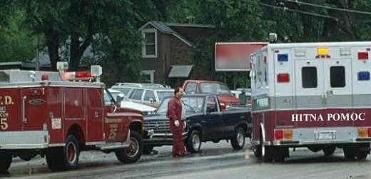

Medical Emergencies Serbian SOLT 1
Application Activities Module 5 Lesson 4

Activity 1
You just witnessed an accident and the police (your partner) would like you to answer some questions. Below are different accident situations and clue words to help you make up a dialogue. Start with the situation of your choice. When you are done with one situation, continue with another, etc.

1. 2. 3.

скијати прозор црвено светло
брзо разбити стати
пасти деца сударити се
ударити се возити 80 км на сат
сломити руку троје повређено

Activity 2
Imagine that you are calling for assistance (your partner). Choose any of the situations in Activity 1 and report the accident. State what has happened, explain when, where, and how many people are injured. Don’t forget to leave your name as well.

Medical Emergencies Serbian SOLT 1
Application Activities Module 5 Lesson 4

Activity 3
You are in the emergency room questioned by a paramedic (your partner). How would you answer his/her questions?

Да ли сте алергични на нешто?
Да ли узимате лекове?
Да ли болујете од неке болести?
Која сте крвна група?
Колико имате година?

Activity 4
Scan the text below and decide if the statements are true or false.

Јуче поподне на аутопуту према Хрватској догодила се тешка саобраћајна несрећа. До несреће је дошло када је камион панчевачке регистрације изненада изгубио контролу и ударио у Мерцедес који је долазио из супротног правца. Возач аута, стар 22 године, је задобио тешке повреде и умро је у колима хитне помоћи на путу до болнице.

T F

1. The car accident happened on the highway to Serbia. _____ _____

2. The driver of the truck caused the accident. _____ _____

3. The driver of the Mercedes was 22 years old. _____ _____

4. The truck driver was badly injured. _____ _____

5. The driver of the Mercedes died on the scene of the _____ _____
accident.

6. The truck had a Pancevo plate number. _____ _____

Answers: 1. F 2. T 3. T 4. F 5. F 6. T

Medical Emergencies Serbian SOLT 1
Application Activities Module 5 Lesson 4

Activity 5
Circulate around the room and find out if your classmates have ever been in an accident. Take down information from each interviewee and report back to your instructor.

Example: Да ли си икада доживео/доживела саобраћајну несрећу?
Какве повреде си имао/имала?

Име | Повреде

Activity 6
Listen to the instructor pretend to make an emergency phone call and answer the questions.

Instructor’s reading:
- Хало, да ли је то хитна помоћ!
- Хитна помоћ, изволите.
- Мој муж се не осећа добро...тешко дише и има болове у прсима.
- Реците ми вашу адресу.
- Улица првог јула 25, Нови Београд. Молим вас пошаљите хитну помоћ!
- Хитна помоћ ће стићи сваки час.
- Плашим се срчаног напада...мој муж има слабо срце.
- Смирите се госпођо, хитна помоћ је на путу.

Medical Emergencies Serbian SOLT 1
Application Activities Module 5 Lesson 4

Activity 6 (continued)

1. Who are the participants of the dialogue?
2. What happened?
3. What address was mentioned in the dialogue?
4. What is the woman afraid of?

Answers: 1. The participants are the woman and the emergency care worker. 2. Her husband is in critical condition. He has problems with breathing and has pain in his chest. 3. Ulica prvog jula 25, Novi Beograd 4. She is afraid that her husband could get a heart attack.

Activity 7
Practice the following dialogue with a partner.

Notifying the police
A = Emergency Operator
B = Accident Witness

A. Identify yourself on the phone (милиционер Марковић).
B. Tell the operator that you have to report a car accident. Say that two people are injured. Request an ambulance.
A. Ask the caller for the location of the accident.
B. Give the location on a highway north of a major town. Estimate the distance from the town in kilometers.
A. Find out what kind of injuries the victim has.
B. Tell the operator that the driver has a head injury. He is in shock.
A. Ask if someone is administering first aid.
B. Tell the operator that a paramedic is at the site of the accident and is administering first aid.
A. Inform B that an emergency doctor is on his way. Tell the caller to stay there until the police arrive.

Medical Emergencies Serbian SOLT 1
Application Activities Module 5 Lesson 4

Activity 8
A pedestrian (your partner) was hit by a car and is lying on the pavement. A passer-by (you) is helping him. Read the questions. Your partner will answer them.

- Шта се десило?
- Где вас боли?
- Шта сте повредили?
- Да ли можете да дишете?
- Да ли вас боли овде?
- Да ли желите да позовем некога?
- Да ли имате породицу?
- Који је број њиховог телефона?

Medical Emergencies Serbian SOLT 1
Skill Enhancement Activities Module 5 Lesson 4

Activity 1
Listen to the instructor read a conversation and choose the best answer.

Instructor’s reading:
- И шта кажете докторе? Какви су резултати?
- Нису лоши Раде, али нису ни одлични.
- Али ја се осећам добро.
- То је у реду. Морате више да једете здраву храну.
Рекао сам вам да избегавате масноћу и слаткише.
Шећер се опет појавио у крви.
- Како могу да се излечим?
- Морате да слушате моје савете и да узимате редовно лекове.

1. The patient’s name is:

a. Раде b. Радомир c. Ранко

2. The doctor says that the test results are:

a. very good b. not bad c. very bad

3. The doctor recommends:

a. vitamins b. medicine c. nothing

4. The patient is suffering from:

a. heart problems b. kidney problems c. diabetes

Answers: 1. a 2. b 3. b 4. c

Medical Emergencies Serbian SOLT 1
Skill Enhancement Activities Module 5 Lesson 4

Activity 2
Scan the text below. Using your knowledge of cognates, fill in the missing parts of the statements.
Riba je jedna od najzdravijih namirnica koje doktori preporučuju u ishrani. Jedna mala porcija ribe (100 g) osigurava:
50% proteina od preporučene dnevne količine
10% željeza, koje je veoma važno za žene,
40% dnevnih potreba kalcijuma
20% dnevnih potreba za vitaminom D
Ako se porcija poveća na 200 grama, potrebe za dnevnim količinama proteina i kalcijuma su podmirene.

- One of the most important foods recommended by doctors is ______________.
- One serving of this food provides 10% of _________ which is very important for women.
- The amount of calcium that one serving provides is __________%.
- The other elements that one serving of this food contains are ____________ and _____________.

Answers: 1. fish 2. iron 3. 40% 4. proteins, vitamin D

Activity 3
Interview your classmates about their eating habits. Ask them what kind of food they eat most often. Is there any particular food that they cannot eat because of health problems, is there any food that they have to eat to improve their health problems. Inform your instructor about your findings.

Medical Emergencies Serbian SOLT 1
Skill Enhancement Activities Module 5 Lesson 4

Activity 3 (continued)

Name: | Mostly eats: | Cannot eat: | Should eat:

Activity 4
Read the news excerpt and answer the questions.

Послије НАТО напада на Југославију, народ се суочава са великом хуманитарном кризом. То су изјавили чланови Црвеног крста. Људи немају посла, немају воде и струје, неки чак ни хране. Џим Карлтон, генерални секретар Црвеног крста (Аустралија) је рекао да је НАТО напад уништио економију Југославије и оставио критичну ситуацију у земљи са више од 500 000 избеглица.

- What is the text about?
- What organization made the statement?
- Who is Jim Carlton?
- What is one consequence of the NATO attack?
- The text refers to what numbers of refugees?

Answers: 1. It is about the humanitarian crisis in the FRY. 2. The Red Cross made the statement. 3. He is the secretary general of the Red Cross. 4. The economy crisis. 5. To the number of 500 000 refugees.

Medical Emergencies Serbian SOLT 1
Skill Enhancement Activities Module 5 Lesson 4

Activity 5
Listen to the following news excerpt and provide the necessary information.

Instructor’s reading
У уторак увече у 19:20 екплодирала је бомба у популарном ресторану Планета Холивуд. Несрећа се догодила у Кејп Тауну, у Јужној Африци. Двоје људи је убијено, а 25 тешко рањено. Узроци овог терористичког напада још нису познати.

Шта?
Где?
Када?
Жртве?
Узрок?

Answers: 1. терористички напад 2. Јужна Африка 3. уторак увече у 19:20 4. двоје мртво, 25 рањено 5. још непознат

Activity 6
Assume the role of a news reporter. Report the news from the previous activity to your classmates in Serbian using the information that you have.

Activity 7
Now imagine that during your stay in the FRY, one of your partners was hospitalized. He/she does not speak Serbian. Using the vocabulary and structures from this lesson act out the scene. One of you will play a doctor, another one will play the patient and the third person will play the interpreter.

Medical Emergencies Serbian SOLT 1
Skill Enhancement Activities Module 5 Lesson 4

Activity 8
The class should be divided in groups of three. Each group should find an interesting news excerpt that is dealing with some type of accident. The representative of each group will come to the board and give a press conference to the rest of the class (journalists). The journalists will ask questions concerning the news.

Activity 9
Match the pictures with the words below.

A. B. C. D.
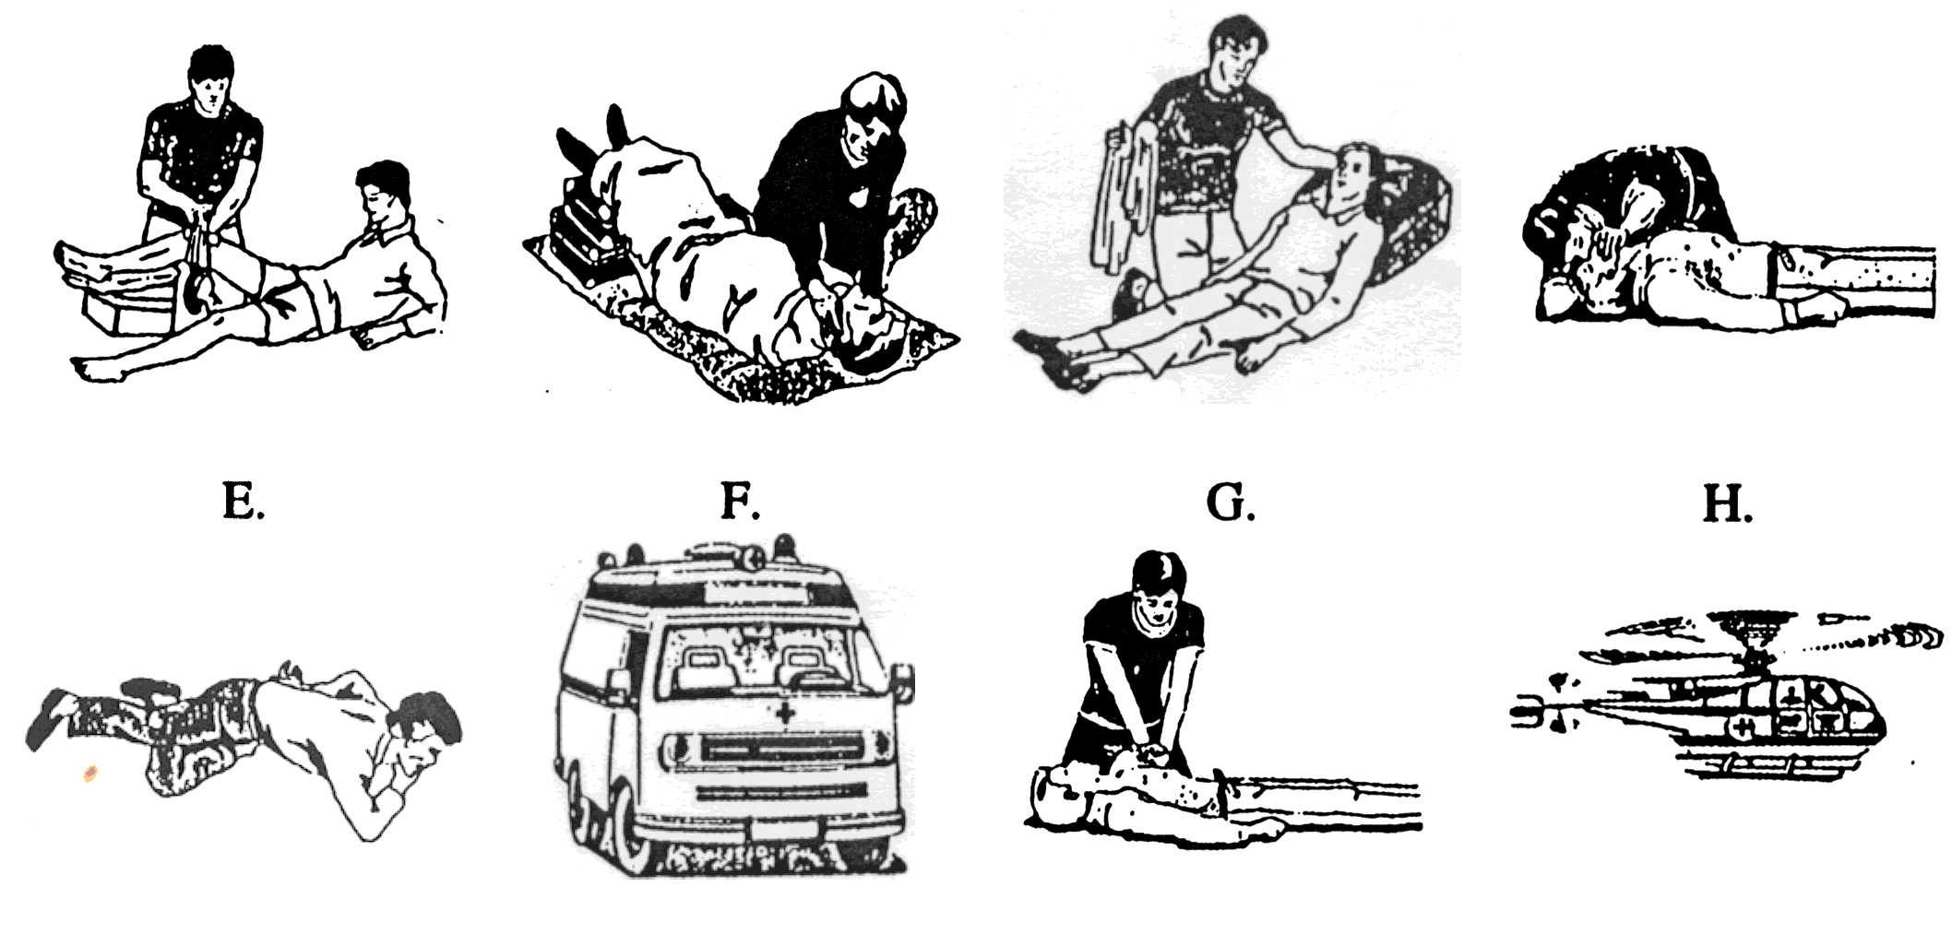

- кола хитне помоћи
- вештачко дисањеk
- повреда колена
- хеликоптер
- срчани напад
- пад (fall)
- губитак свести
- болови у стомаку

Answers: 1. F 2. D 3. A 4. H 5. G 6. E 7. C 8. B

Medical Emergencies Serbian SOLT 1
Homework Module 5 Lesson 4

Activity 1
Vladimir Popovic was admitted to the hospital this morning. Listen to what the doctor says to Vladimir’s wife and mark the words that are mentioned.

Audio Script
Ваш супруг је имао тежак ударац у главу. Прегледали смо га и сад се осећа добро, али ће морати да остане у болници два дана.

a. long
b. bone fracture
c. two days
d. head
e. state is good
f. overestimated
g. neck
h. right hip

Answers: c, d, e,

Activity 2
Read the text and mark the true statements.

Maja Popović iz Vranja, stara 25 godina, poginula je juče u saobraćajnoj nesreći u Ulici Vuka Karadžića u Vranju. Na nju je naletelo vozilo marke BMW sa registarskom tablicom HN-54-08. Za volanom se nalazio 20-godišnji Petar Mitrović.

- This text is about a traffic accident.
- The victim of the accident is a young man.
- The accident happened outside of the city of Vranje.
- Only one car was involved in this accident.
- The victim of the accident was the driver of a BMW.

Answers: 1, 4

Medical Emergencies Serbian SOLT 1
Homework Module 5 Lesson 4

Activity 3
Read the vegetarian diet below and answer the questions.

DIJETA ZA VEGETARIJANCE
Ujutro: | Velika čaša svežeg voćnog soka
Do 12 sati: | Samo sveže voće
U podne: | Sveža salata, sveže povrće, tost od brašna ili supa
Glavni obrok: | Sok od svežeg povrća, krompir, kuvani pirinač, povrće, salata.
Večera: | Jesti ranije

- If you follow this diet, what would you eat/drink in the morning?
- At what period of the day would you eat only fresh fruits?
- What meal, according to this diet, should be taken earlier during a day?
- What does the diet recommend for the main meal?

Answers: 1. Only a cup of fresh fruit juice. 2. until noon 3. supper 4. It recommends vegetable juice, potatoes, steamed rice, vegetables, salad.

Activity 4
Pretend you are making an emergency call. State your name, the location of the accident, the number of victims, a description of their injuries and condition, plus possibly chronic illness or allergies. Present your emergency call to the rest of the class the next day.

Име и презиме: _______________________________________________________

Место несреће: _______________________________________________________

Време несреће: _______________________________________________________

Број повређени: _______________________________________________________

Повреде: _____________________________________________________________

Алергије:_____________________________________________________________

Medical Emergencies Serbian SOLT 1
Homework Module 5 Lesson 4

Activity 5
Use the information from Activity 4 and write a short news report about a traffic accident. The instructor will check your work the next day.

________________________________________________________________________________________________________________________________________________________________________________________________________________________________________________________________________________________________________________________________________________________________________________________________________________________________________________________________________________________________________________________________________________________________________________________________
________________________________________________________________________
________________________________________________________________________________________________________________________________________________________________________________________________________________________

