SOLT Serbian Module 3 Lesson 1

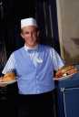

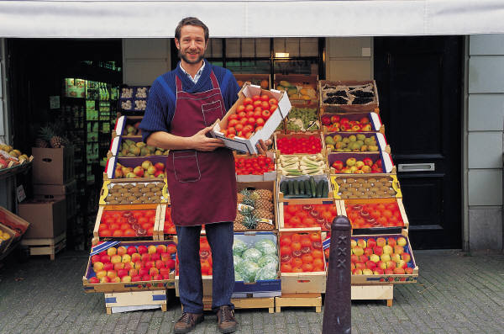

Food and Drink
Food and Drink Serbian SOLT 1
Objectives Module 3 Lesson 1

During this lesson, the students will learn about food and drink. Under this Terminal Learning Objective, the students will learn five tasks: offer food and drink, accept invitations, discuss quality and quantity of food items, order a meal in a restaurant, and shop for goods/services. At the end of the lesson, the students will be able to:

- Accept invitations. This task will include:
- Extend invitations
- Accept invitations
- Talk about courtesy visits to the TR
- Pay compliments to your friend
- Ask and answer simple questions about others’ state of well being

- Offer food and drink. This task will include:
- Plan a dinner party
- Invite somebody for dinner at your house
- Plan a picnic
- Compare different types of food in the US and TR

- Discuss quality and quantity of food items. This task will include:
- Specify the meal times for breakfast, lunch, and dinner
- Discuss dishes and utensils
- Talk about food habits
- Discuss food preparation

- Order a meal in a restaurant. This task will include:
- Make a restaurant reservation
- Talk about cafeteria and fast food stand
- Read items on the menu
- Ask about items on the menu
- Identify food items and beverages
- Talk about the variety of ethnic dishes

- Shop for goods/services. This task will include:
- Plan the grocery list
- Shop for groceries
- Purchase food items at a butcher shop, a bakery, a grocery store, an open-air market, and a super market
- Recognize types of packaging used in the TR markets
- Purchase fuel
- Purchase personal items
- Purchase water
Food and Drink Serbian SOLT 1
Introduction Module 3 Lesson 1

Being hungry is a common thing but starvation should not be. Therefore it is imperative that you learn the basic steps of how to ask for food in the target country as well as to pay bills in restaurants and do theshopping. This lesson will give you the information about eating habits and shopping in the Federal Republic of Yugoslavia. Yugoslavia is a great country for food lovers because its cuisine was influenced by different cultures: Greek, Austrian, Italian and Turkish. There is everything for everyone. But once you are there, make sure to taste the popular ћевапчићи (small grilled sausages made of ground meat).

Tip of the day
When invited for dinner in the FR of Yugoslavia it is customary to take a small gift for домаћина and домаћицу (host and hostess). The gift is usually a bottle of wine, a box of chocolates or a bouquet of flowers.

Exercise 1
Забава (A Party)
Mrs. and Mr. Петровић are planning a dinner party. They will invite their closest friends and relatives. Listen to the instructor read the conversation. Afterwards do the role-play with your partner and read the dialog between Mr. and Mrs. Petrovic.

Милан: Данице, да ли си већ позвала све госте?
Даница: Позвала сам Поповиће, Станиће, Симиће, тетку Раду наравно, и... мислим да је то све.
Милан: A стриц Ранко и стрина Коса? Њих си заборавила.
Даница: Oх, у праву си. Можеш ли ти да их позовеш?
Милан: У реду. У међувремену ти можеш да ставиш пиће у фрижидер.
Даница: Шта си купио?
Милан: Све што си рекла: ракију, вино, кока колу и сокове.
Даница: А ликер?
Милан: Ех, знао сам да ћеш то да ме питаш. Ево, и ликер је ту.

Food and Drink Serbian SOLT 1
Introduction Module 3 Lesson 1

Exercise 2
Decide if the following statements are true or false.

T/F

1. Mrs. Petrovic has invited four families. _________
2. Mr. Petrovic did not invite uncle Ranko. _________
3. Mrs. Petrovic will invite uncle Ranko. _________
4. Mr. Petrovic didn’t buy juices. _________
5. Mrs. Petrovic is happy because Mr. Petrovic _________
didn’t buy liqueur.

Exercise 3
Позив на вечеру (A dinner invitation)
While Mrs. Petrovic is busy arranging things in the kitchen, Mr. Petrovic is phoning aunt Kosa and uncle Ranko to invite them for dinner.

- Listen to the instructor read the conversation and do the role-play with your partner.
- Fill in the table below the necessary information.

Милан: Стрина Косо, овде Милан.
Коса: Здраво Милане. Шта има?
Милан: Интересује ме да ли сте ти и стриц Ранко слободни сутра увече у седам? Даница и ја вас позивамо на вечеру.
Коса: Oх, хвала. Ја ћу сигурно да дођем али не знам за Ранка. Он ради сутра увече.
Ја ћу да га питам. Важи?
Милан: Важи стрина Косо.

Food and Drink Serbian SOLT 1
Introduction Module 3 Lesson 1

Exercise 3 (continued)

1. Who are the speakers?
2. What are they talking about?
3. What time is mentioned?
4. Who cannot come?
5. The reason for not coming?

Одлазак на излет (Going to a picnic)
During a dinner party at their house, the Petrovic’s and their guests decide to have a picnic on Sunday at a nearby lake. While the men are talking about business, the women are discussing what to prepare for the picnic. Read the dialog.

Даница: Милан и ја ћемо да донесемо роштиљ и да припремимо месо.
Весна: Милан прави одличне пљескавице и ћевапћиће! Славко и ја ћемо онда да донесемо пиће.
Маја: Ја ћу да испечем колаче.
Радмила: Ја ћу онда да направим домаћи хлеб и погачу.
Даница: Сви волимо твоју погачу Радмила. Направи више, за сваки случај.
Гордана: Ја ћу да донесем сенф, мајонезу, кечап, бибер, со, салату.
Тетка Рада: А штa ћу ја да припремим децо?
Даница: Ти не требаш ништа да радиш тетка Радо. Само седи и уживај.

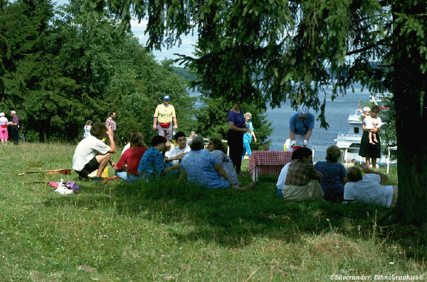

Food and Drink Serbian SOLT 1
Introduction Module 3 Lesson 1

Exercise 4
Read the dialog together and underline all nouns that describe food. In the table provided below, write the Serbian food cognates.

Exercise 5
Do you go on picnics? Who do you usually go with? Compare your picnic with the one mentioned in the text. How does the picnic in the US differ from the one in the FR of Yugoslavia? What are the differences and similarities? Ask your instructor to tell you more about this topic.

Expressions

У праву си. | You are right.
У реду. | OK
Шта има? | What’s up?
Важи? | OK
Направи више, за сваки случај. | Make more, just in case.
Седи и уживај! | Sit and enjoy!

Food and Drink Serbian SOLT 1
Introduction Module 3 Lesson 1

Tip of the day
The Yugoslav family usually has доручак (breakfast) in the morning around 8 or 9 A.M. Ручак (lunch) is served between 2 and 3 PM, and вечера (dinner) is usually at 7 or 8 PM.

Шта једемо?

Exercise 6
Read the text about Mirko and Rada and their food habits, than find the information for the questions written below.

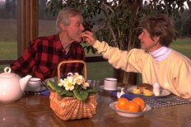

доручак ручак
За доручак обично једемо нешто лагано: кувана јаја, бутер, мармеладу и тост. Мирко воли да попије чај, а ја обично узмем млеко.

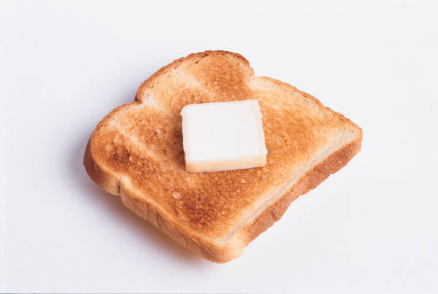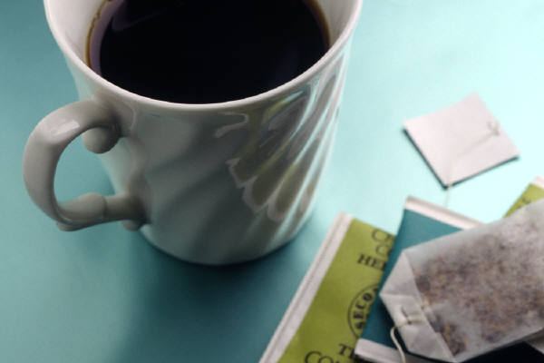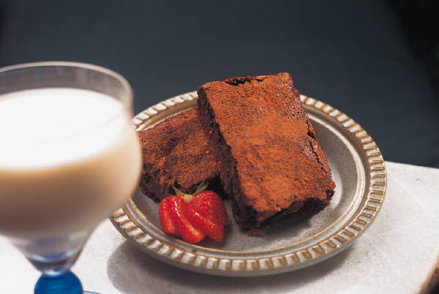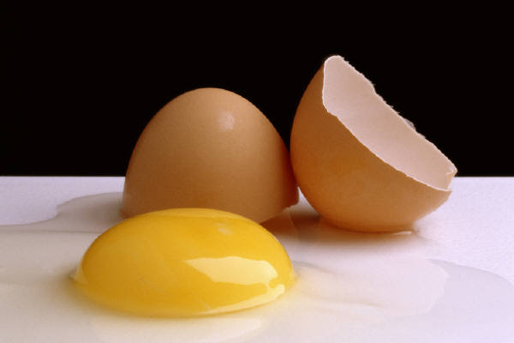
Ручак је наше главно јело. За ручак волимо да имамо супу. Осим супе једемо све врсте поврћа: грашак, кромпир, паприку. Често једемо рибу.
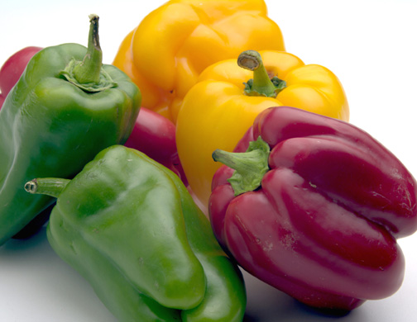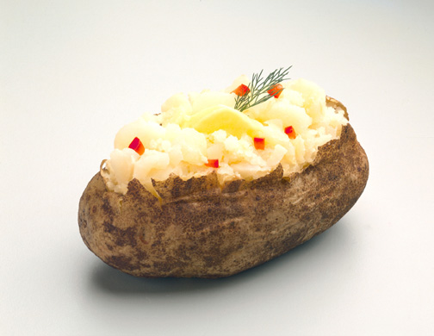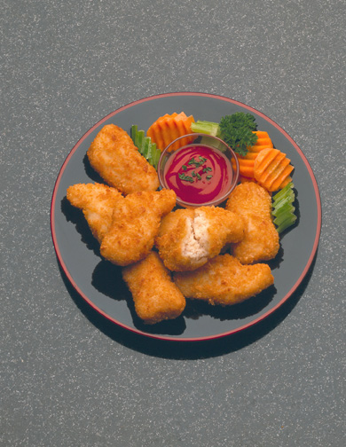

вечера
Често избегавамо да вечерамо. Ако већ нешто поједемо то је обично воће: јабука, крушка, банана.

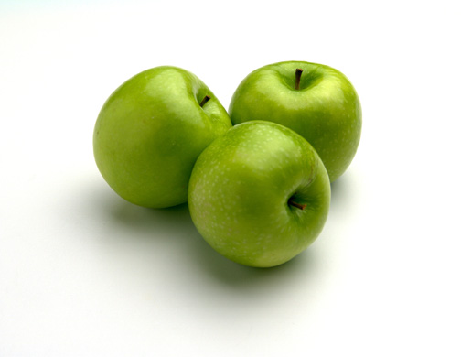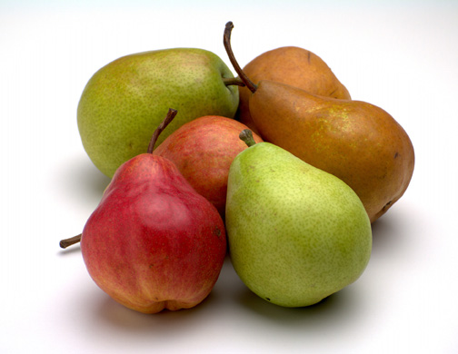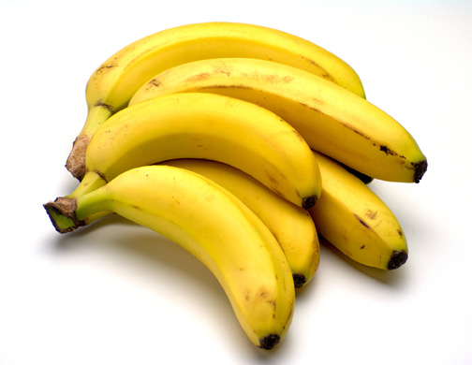

Food and Drink Serbian SOLT 1
Introduction Module 3 Lesson 1

Exercise 6 (continued)

1. Do Mirko and Rada prefer a light or a heavy breakfast? Find the word in the text that
confirms your answer.
2. What do they like to eat in the morning?
3. According to what they eat for lunch, do they eat healthy food? Why?
4. Are Mirko and Rada vegetarians? Find the word or words that confirm your answer.
5. What do they eat for supper?

Exercise 7
You want to find out what your partner eats for breakfast, lunch and supper. Ask him/her questions and write down your notes. Report the information to the class. Please refer to the food list in the section Grammar Notes.

Прибор за јело (Eating utensils) 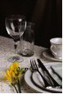



кашика

виљушка тањир нож

Food and Drink Serbian SOLT 1
Introduction Module 3 Lesson 1

Навике (Habits)

Exercise 8
Look at the image and the statements written about food habits. Decide to whom each statement belongs: the person number 1 or the person number 2. Compare your work with your partner.
No. 1. No. 2.


мршав дебео

1. Ја једем шест пута дневно. 2. Ја волим све да једем.
3. Ја једем мало. 4. Ја једем много.
5. Ја не волим поврће али волим месо. 6. Ја волим воће и рибу.
7. Хамбургери су моја омиљена храна. 8. Ја никад не вечерам.
9. Ја волим да пијем пиво. 10.Ја мрзим спорт.

Tip of the day
At the beginning of a meal, people usually say Пријатно (Good appetite).

Годишњица
This weekend, Milan and Danica are celebrating their 15th wedding anniversary. Milan phones the restaurant “Два голуба” to make a table reservation. Listen to the instructor read their conversation.

Instructor’s reading:
Рецепциониста: Ресторан “Два голуба”. Изволите.
Милан: Добар дан. Хтео бих да резервишем сто за двоје за суботу увече у 8.
Рец. Само тренутак да видим да ли имамо слободно место. Рекли сте сто за двоје, субота увече у осам часова?
Милан: Тако је.
Food and Drink Serbian SOLT 1
Introduction Module 3 Lesson 1

Годишњица (continued)

Рец. Да имамо слободан сто. Ваше име је?
Милан: Милан Петровић.
Рец. Ваш број телефона?
Милан: 345-552
Рец. У реду господине Петровић. Имате резервацију за суботу увече. Број стола је 23.
Милан: Хвала.
Рец. Молим и пријатно.

Exercise 9

Read the dialog between Milan and the receptionist. Then, without looking at the original version fill in the missing words in the text below.

Рецепционар: Ресторан ___________ Изволите.
Милан: Добар дан. Хтео бих да ______________ сто за двоје за суботу увече у 8.
Рец. Само тренутак да видим да ли имамо ___________ место. Рекли сте сто за _______, субота _______ у осам ________?
Милан: Тако је.
Рец. Да имамо слободан сто. ____________________?
Милан: Милан Петровић.
Рец. Ваш _____ телефона?
Милан: 345-552

У ресторану

Келнер: Добро вече. Изволите.
Милан: Ја ћу парадајз чорбу и бечку шницлу.
Даница: Ја ћу да узмем говеђу супу, рибу и кромпир салату.
Келнер: Шта желите за пиће?
Милан: Ја ћу чашу вина.
Даница: И ја ћу чашу вина.
Милан: И донесите одмах рачун молим.
Келнер: Нема проблема.
Food and Drink Serbian SOLT 1
Introduction Module 3 Lesson 1

Exercise 10
Now it is your turn. You want to make a restaurant reservation. Your partner is a receptionist. Once you make a reservation, pretend that you are in a restaurant and order the items from the menu given below. Your partner will take the orders.

Предјела
Италијанска салата 2,50 динара
Грчка салата 2,50 динара
Тартар бифтек 7,50 динара
Хладна пршута 12 динара
Пилећа салата 4 динара

Главна јела
Парадајз чорба 3,50 динара
Говеђа супа 4,50 динара
Бечка шницла 18 динара
Месо на жару 22 динара
Ћевапћићи 18 динара
Бифтек 25 динара

Пића
Воћни сокови 1,50 динара
Пиво 2 динара
Жестока пића 4 динара

Tip of the day
Most towns in the FR of Yugoslavia have тржницу (market place) where people can buy fresh fruits, vegetables, cheese and eggs, directly from the grower.

Food and Drink Serbian SOLT 1
Introduction Module 3 Lesson 1

Exercise 11
Mrs. Петровић is going grocery shopping. Look at her grocery list below and make a note of the items she has to buy, in English.

1 hleb
10 jaja
1 margarin
1 mleko
1kg banana
1 kg jabuka
250 g sira
1 kg krompira
1 kg paradajza

________________________________________________________________________________________________________________________________________________________________________________________________________________________________________________________________________________________________________________________________________________________________________

Food and Drink Serbian SOLT 1
Grammar Notes Module 3 Lesson 1

Храна (food)

пршута (smoked ham)
Супе, чорбе (soups) месо на жару (grilled meat)
говеђа супа (beef soup) печење (roast)
пилећа супа (chicken soup) млевено месо (ground meat)
супа од поврћа (vegetable soup) риба (fish)

Поврће (vegetables) Зачини (spices, dressings)
kромпир (potatoes) со (salt)
парадајз (tomatoes) уље, зејтин (oil)
паприка (pepper) шећер (sugar)
пасуљ (beans) сирће (vinegar)
кукуруз (corn)
целер (celery)
гљива (mushroom) Пића (drinks)
бели лук (garlic) воћни сок (fruit juice)
зелена салата (lettuce) вино (wine)
лук (onion) пиво (beer)
першун (parsley) кафа (coffee)
спанаћ (spinach) чај (tea)
пиринач (rice) ракија (brandy)
краставац, ци (cucumber)

Воће (fruits) Хлеб (bread)
лубеница (watermelon) бели хлеб (white bread)
диња (melon) црни хлеб (dark bread)
јагода (strawberry) кифла (crescent, roll)
вишња (sour cherry) ражеви хлеб (rye bread)
трешња (cherry) кукурузни хлеб (corn bread)
крушка (pear) земичка (bun)
ананас (pineapple)
бресква (peach) Разно (various)
лимун (lemon) млади сир (cottage cheese)
грожђе (grapes) слатка павлака (whipped cream)
поморанџа (orange) кисела павлака (sour cream)
јабука (apple) јогурт (yogurt)
сладолед (ice-cream)

Месо (meat) пита од сира (cheese pie)
говедина (beef) пита од меса (meat pie)
пилетина (chicken) млeчни производи (dairy products)
прасетина (pork) торта (cake)
телетина (veal) кестен пире (chestnut puree)
јагњетина (lamb) штрудла од јабука (apple strudel)
Food and Drink Serbian SOLT 1
Grammar Notes Module 3 Lesson 1

Personal Pronouns in the Accusative Case (long and short form)

English Serbian
I saw them yesterday. Видео сам их јуче.
Peter invited Mark and me to dinner. Петар је позвао Марка и мене на вечеру.

Personal pronouns in Serbian have a long and short form in the accusative case.

Personal Pronouns

Nominative Accusative
Long form Short form
ја мене ме
ти тебе те
он њега га
она њу ју, је
оно њега га
ми нас нас
ви вас вас
они њих их

Vocabulary

The short form is used very often, but it cannot stand at the beginning of a sentence. The long form is used to emphasize something and it can stand at the beginning of a sentence. Long forms are also used after the conjunctions a and и and with prepositions.

Example:

Видим њега а не њу. (emphasis) I see him but not her.
Одавно нисам добио писмо од тебе. I have not received a letter from you in a long time.

Exercise 1
Fill in the missing personal pronouns.

1. Марко: Ја волим Марију. Да ли _____ ти волиш?
Петар: Да, ја _____ много волим.
2. Јелена: Да ли познајете човека на улици, госпођо Папић?
Госпоћа Папић: Не, не познајем ____.
3. Сања: Да ли си видела Марију?
Нада: Видела сам _____ јуче.
Food and Drink Serbian SOLT 1
Grammar Notes Module 3 Lesson 1

Exercise 1 (continued)

4. Славко: Пријатељи су ____ позвали јуче на вечеру.
Зоран: Да ли су позвали и _______?
Славко: Да, позвали су _____.

The Genitive Partitive

A genitive may have a partitive meaning. It doesn’t refer to the whole mass but only a part of it. The English equivalent of the genitive partitive are: of, any, some, no, not any, etc.

Examples:

За доручак једемо два јаја, мало хлеба и комад сира.
For breakfast, we eat two eggs, some bread and a piece of cheese.

Обично пијем чашу млека или чаја.
Usually, I drink a glass of milk or tea.

Желим џак брашна, корпу јабука, литар вина и килограм сира.
I want a bag of flour, a basket of apples, one liter of wine and a kilogram of cheese.

Exercise 2

Look at the shopping list below and write down in Serbian what are you going to buy.

Shopping list

2 kg beans __________________________
3 l milk __________________________
2 kg apples __________________________
12 eggs __________________________
250 g cheese __________________________

Food and Drink Serbian SOLT 1
Vocabulary Module 3 Lesson 1

бензин | gas
бензинска станица, е | gas station
виљушка, е | fork
врста, е | kind, sort
главно јело | main dish
гост, и | guest
грашак | peas
доручак | breakfast
Ево! | here!
жилав, а, о (месо) | tough
забава, е | party
заборавити | to forget
заменити | to exchange
здрав, а, о | healthy
знати | to know
избор, и | selection, s
избегавати | to avoid
изгребан, а, о | scratched
испећи (пећи) | to bake
јеловник, јеловници | menu
кашика, е | spoon
кечап | ketchup
кисели купус | sauerkraut
кобасица, е | sausage, s
колач, и | cake
кувана јаја | boiled eggs
купац, купци | buyer
лењ, а, о | lazy
ликер, и | liqueur
љут, а, о | spicy; mad
мајонеза | mayonnaise
мислити | to think
навика, е | habit
направити (правити) | to make
*наручити | to order
немогуће | impossible
па | and (then)
паприкаш, и | stew
патка, е | duck, s
платити | to pay
Food and Drink Serbian SOLT 1
Vocabulary Module 3 Lesson 1

пљескавица, е | hamburger
погача, е | type of bread
позив, и | invitation
поцепан, а, о | ripped
предјело, а | appetizer
рачун, и | bill
резервисати | to make a reservation
роштиљ, и | grill
ручак | lunch
Само тренутак! | Just a moment!
самопослуга, е | super market
свеж, а, е | fresh
сенф | mustard
сигурно | certainly
ставити | to place, to put
шницла, е | cutlet, s
тањир, и | plate
тост | toast
тржница, е | market
ту | here
ћевапчић, и | grilled meatball, s
уживати | to enjoy
уморан, а, о | tired (m, f, n)
флаша, е | bottle, s
фрижидер, и | refrigerator
Хајде! | Let’s go!

Food and Drink Serbian SOLT 1
Culture Notes Module 3 Lesson 1

If you are planning formal dining in one of theYugoslav restaurants, it is a good idea to reserve a private table. In most restaurants guests receive the bill together with their order. It is not necessary to pay the bill immediately upon receiving it, but this really varies from restaurant to restaurant.

Shopping hours differ from store to store. Most private stores are open late in the evening, some even until midnight. The shopping hours for the government stores are usually from 7A.M.- 8 P.M. on Monday through Friday. On Saturday, the shopping hours are shorter and the stores are usually closed on Sundays. This again excludes the private stores.

In contrast to some North American stores, one cannot buy prescription or non-prescription drugs in any Yugoslav store. There is a special place called апотека where these drugs are sold. On the other hand, one can buy alcohol beverages in almost every grocery store or supermarket.

Food and Drink Serbian SOLT 1
Application Activities Module 3 Lesson 1

Activity 1

Идемо на излет! You and your partner are going on a picnic with your mutual friends. By using phrases given below, say what each of your friends is going to do.

Example: Марко ________ пиће. донети
Марко ће да донесе пиће.

1. Милан и Јелена ________________ месо. припремити
2. Сања _____________ погачу. направити
3. Славко _____________ лопту. донети

4. Бојан _______________ кифле и хлеб. купити

5. Ја _____________ ауто. возити

Activity 2
Compare the meals in the US with those in the FR of Yugoslavia. Talk about the hours when breakfast, lunch and supper are served in your country. Is the breakfast in the US usually light (continental breakfast) or heavy? What about lunch and supper? Make a list of differences and similarities between the US and the FRY considering this topic.

Сличности

(Similarities)

Разлике

(Differences)

Food and Drink Serbian SOLT 1
Application Activities Module 3 Lesson 1

Activity 3
Find out what food habits your partner has. Does he/she have a healthy lifestyle or not. Report your findings to the class. You can ask any question you want. Below are some question options and answers.

You: Да ли пушиш?  Your partner: Пушим/Не пушим.

Да ли пијеш кафу?  Не још. (Not yet.)

Да ли једеш много меса? 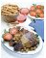 Не. Хоћу да останем здрав. (healthy)

Да ли доручкујеш ујутро? 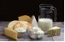 Не. Превише сам лењ/лења. (lazy)

Да ли пијеш алкохол? 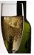 Нећу да постанем пијаница. (alcoholic)

Да ли често трчиш? 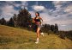 Никада.Увек сам уморан/уморна.(tired)

Здрав живот

Food and Drink Serbian SOLT 1
Application Activities Module 3 Lesson 1

Activity 4
You are in a restaurant just eating the meal you ordered, but something is wrong with the meal. Call the waiter (your partner) and complain about the meal. You can use the expressions given below.

Ово није говећа супа него пилећа.
Пиво није хладно.
Месо је жилаво. (tough)
Кафа је прејака. (too strong)
Салата није свежа. (fresh)
Јело је прељуто. (too spicy)

Activity 5
Here is the recipe for making the popular Serbian hamburger (српска пљескавица). Read the recipe and answer the questions written below.

Српска пљескавица
Рецепти

Потребно је:
- 500 kg млевеног меса
- 100 g свеже сецкане паприке (слатке или љуте),
- 100 g лука, 2 чешња белог лука,
- со, бибер, уље за роштиљ.
У млевено месо додати паприку, сецкани лук, бели лук, со, бибер. Добро све измешати и оставити да стоји на хладном месту око 30 минута. Формирати пљоснате погачице величине длана, пећи пљескавице на роштиљу око 10 минута. Готове пљескавице прелити луком, паприкама или парадајзом.

1. What kind of meat do you need for this recipe?

2. Name the spices needed for a Serbian hamburger.

3. How long do you have to grill the hamburger?

5. What can you put over the Serbian hamburger once it is done?

Food and Drink Serbian SOLT 1
Application Activities Module 3 Lesson 1

Activity 6
Choose a role of a customer or a salesperson with your partner and follow the instructions given for each shopping situation.

Situation 1. У продавници (In a store)
You are buying various items in a grocery store in Belgrade. Complete your part of the dialogue.

- I would like to buy apples, pears and strawberries.
- Колико желите?
- 1kg apples, 2kg pears and 1/2kg strawberries. Are they fresh?
- Да, све је свеже. Јутрос је стигло.
А. Do you have sour cream?
B. Жао ми је али немамо.
А. Do you have fresh bread and rolls?
B. Колико ћете хлеба и кифли?
- 1 bread and 3 rolls.
- Желите још нешто?
- No, thanks. That’s all. How much is all that together?
- 9 динара.
А. Do you have a bag?
B. Кеса је 50 пара.

Situation 2.
Select one item from each box and ask for them. Ask your partner for the price of each merchandise, say how much/how many items or amount you need and ask for the bill.

1. 1kg apples
2 kg potatoes
½ kg tomatoes
½ kg pears

2. 250 g. pork
500 g. veal
750 g. lamb
200 g. salami

3. 1l milk
½ l oil
500 g cheese
1 kg coffee

Food and Drink Serbian SOLT 1
Application Activities Module 3 Lesson 1

Activity 7
Study the advertisements below. Answer the questions and compare your work with a partner.

Женске хаљине по Дечје панталоне
повољној цени. Само 35 ДИН
85 ДИН
Софа и орман
Италијанске ципеле 150 ДИН
повољно 70 ДИН
Стерео повољно
Женске ташне од 100ДИН
коже 45 ДИН

1. How much would you have to pay:

    - for ladies’ dresses?
    - for children’s trousers
    - for Italian shoes
    - for ladies’ purses
    - for a stereo
    - for a sofa and a cabinet?

Activity 8
You are not happy with the merchandise you bought this morning. You decide to return it to the store. Your partner is a salesperson. Here are some useful expressions.

Expressions for you: Expressions for your partner:

Јутрос сам купио/купила ___________. Жао ми је.
Он/она/оно/ је поцепан, а, о. (ripped) То jе немогуће... (impossible)
је у квару. (broken) Морам да питам менаџера.
Food and Drink Serbian SOLT 1
Application Activities Module 3 Lesson 1

Activity 8 (continued)

не ради. Заменићемо га/је.
је изгребан, а, о. (scratched)
труо, трула, труло (rotten)
Хоћу да га/је заменим. (exchange)
Хоћу назад моје паре.

Activity 9.
Read the following advertisement. Decide whether the statements about it are true or false.

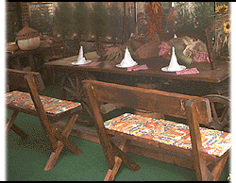
Ресторан се налази у центру града. Ако желите да проведете пријатне тренутке онда сте на правом месту. Поред традиционалне кухиње нудимо све врсте јела интернационалне кухиње и рибље специјалитете. Капацитет нашег ресторана је 250 места. Организујемо коктеле, рођенданске и остале забаве. Увече Вас забавља локални оркестар.

T F

1. This restaurant is outside of the city. ______ ______

2. In this restaurant one can eat only traditional food. ______ ______

3. There is music every evening. ______ ______

4. 250 people are visiting the restaurant daily. ______ ______

5. All different typesof entertainment are organized ______ ______
here.

Food and Drink Serbian SOLT 1
Skill Enhancement Activities Module 3 Lesson 1

Activity 1
Listen to the instructor read about Зоран and Маја ordering a meal in a restaurant, then fill in the necessary information in the box provided below.

 | Зоран | Маја
appetizer
main meal
dessert
drinks

Activity 2
Mr. Popovic is making a reservation in a restaurant. Listen to the instructor read his conversation with the receptionist and provide in the table the necessary information.

For how many people is a reservation made?
For what day?
At what time?
The table number is?
Food and Drink Serbian SOLT 1
Skill Enhancement Activities Module 3 Lesson 1

Activity 3
What questions produce the following answers?
a.

Жао ми је али немамо слободан сто.

б.
Имамо. Два килограма пасуља коштају 4 динара.

ц.
2 килограма грожђа.

Activity 4
Choоse the statements that are appropriate for the image below.


  - Он не воли спорт.
  - Он једе нездраву храну.
  - Он је у форми.
  - Он је дебео.
  - Он је мршав.
Food and Drink Serbian SOLT 1
Skill Enhancement Activities Module 3 Lesson 1

Activity 5
Read the statement about Dejan’s food habits and answer with true or false.

Свако јутро обично попијем чашу кока коле и поједем 5 кифли. Ја уживам да једем и обично једем све а највише месо са роштиља. Волим нарочито да једем колаче. Волим да пијем кафу и пушим цигарете. Дневно требам једну кутију цигарета. Највише једем увече пре спавања.

T/F

1. Dejan eats a lot. _______
2. Dejan eats healthy food. _______
3. He doesn’t like meat. _______
4. He smokes only one cigarette per day. _______
5. He likes sweets. _______
6. Dejan does not eat in the evening. _______

Activity 6
Read the advertisement below and answer the questions that follow.

Ресторан - Два голуба
Улица Петра Прерадовића 7
Телефон 011-345-886

Сваке седмице други јеловник

Одлична понуда – Задовољни гости

Ресторан располаже са 150 места – тераса напољу може да прими 50 гостију – на прелепом месту са погледом на реку

Приређујемо све врсте забава од рођендана, венчања, годишњица и осталих породичних славља
Госте забавља група Тамбураши

Радно време од 10 сати ујутро до 12 сати увече
Не радимо само првог дана Божића

Food and Drink Serbian SOLT 1
Skill Enhancement Activities Module 3 Lesson 1

Activity 6 (continued)

  - What type of advertisement is this?
  - What is offered here?
  - What can be celebrated here?
  - Do the guests get always the same menu or does the menu change from week to week?
  - When is the restaurant closed?
  - What is the name of the entertainment group?

Activity 7
Connect the following sentences.

1. Јелена иде | А. много да једе.
2. Купићемо воће | Б. да купите?
3. То ћемо да платимо | Ц. кошта?
4. Колико то | Д. је вегетаријанац.
5. Горанов отац | Е. да посети пријатеље.
6. Владо не воли | Ф. 80 динара.
7. Шта желите | Г. свеже воће?
8. Да ли имате | Х. и поврће.

Activity 8
You want some bread, butter, coffee, potatoes, fruit and vegetables, but your shopping list got a bit confused. Match the items with the most likely quantities.

1. пет килограма а. млека

2. сто грама б. саламе

3. два литра ц. кафе

4. један комад д. сока

5. литар е. сира

6. двесто грама ф. кромпира

Food and Drink Serbian SOLT 1
Skill Enhancement Activities Module 3 Lesson 1

Activity 9
Српска пљескавица и ћевапчићи are very popular dishes in the FR of Yugoslavia. What about you and your country? What is the popular dish in the region you are coming from? Do you know how to prepare it? In the space provided write what you need to make this dish. Exchange your answer with your partner.

________________________________________________________________________________________________________________________________________________________________________________________________________________________________________________________________________________________________

Activity 10

The following shopping situations are taking place in different stores. Listen carefully to the instructor and answer the questions.

1. Where is situation No.1 taking place? What did the customer buy?

2. What did the customer want to buy in situation 2.

3. Where was situation No. 3 taking place and how much of the product did the

customer buy?

4. What was the last question that the salesperson asked in the situation No. 4?

Activity 11
Look again at Activity 6 in this section. Invite your partner to a dinner in this restaurant. Your partner will ask you questions based on the restaurant advertisement and you will provide him/her with the answers.
Food and Drink Serbian SOLT 1
Homework Module 3 Lesson 1

Activity 1
Complete the sentences with the appropriate words from the Jumble Box.

- Милане, позивамо ____ на вечеру у суботу увече.
- Јелена је купила хлеб, _______ и млеко.
- Интересује ме да ли сте _________ поподне?
- Шта ће Маја да __________?
- За доручак ___________ једемо _______ лагано.
- Хамбургер је Сањина ___________ храна.
- Сутра поподне ____________ на излет.
- Милан и Рада воле да једу у ___________.
- Он воли да пије ____________.
- Резервисао сам _______ за двоје.

ресторану обично идемо те донесе

пиво омиљена сто павлаку

слободни нешто

Activity 2
Determine which item in each of the following groupings does not belong there.

1. _______ парадајз 2. _______ купити
_______ тенис _______ платити
_______ паприка _______ јести

3. _______ пиво 4. _______ пити
_______ млеко _______ говорити
_______ виски _______ јести

5. _______ салата 6. ________ со
_______ пилетина ________ бибер
_______ поврће ________ кафа

Food and Drink Serbian SOLT 1
Homework Module 3 Lesson 1

Activity 3
Milan and Sanja are going shopping. Listen to their dialogue and choose the correct answer.

- Sanja and Milan are going shopping:

a. in the supermarket b. at the market c. in the department store

- They will buy:

a. 1kg pears b. 1kg pears and strawberries c. 1kg strawberries

- What is expensive?

a. cherries b. peaches c. potatoes

- Milan and Sanja are going shopping:

a. in one hour b. later c. right away

Activity 4
Sort these words into specific columns.

трешње, шаргарепа, грашак, јогурт, купус, кромпир, павлака, поморанџа, парадајз, крушка, банана, маргарин, млеко, јагоде, јабука, лук, бели лук, пасуљ, паприка

Млечни производи
Воће
Поврће

Food and Drink Serbian SOLT 1
Homework Module 3 Lesson 1

Activity 5
Read what Monica wrote in her diary today and answer the questions that follow.

пробати хаљину (to try on)
приметити (to notice)
отићи (to go back, to leave)

5. јули 2000

Ујутро сам одлучила да идем у куповину. Хтела сам да купим нешто ново. Остала сам у продавници два сата али сам купила лепу црвену хаљину. Пробала сам је код куће и приметила да је хаљина поцепана. Отишла сам назад у продавницу да заменим хаљину. Била сам веома љута. Продавачица је позвала менаџера али сам добила паре назад.

1. When did Monica decide to go shopping?

2. What did she buy?

3. Why was she upset when she came home?

4. What did she do with her dress?

5. Whom did the salesperson call?

6. What happened at the end?

Food and Drink Serbian SOLT 1
Homework Module 3 Lesson 1

Activity 6
Place the items from the menu on the left into the appropriate group on the right.


Ресторан МОРЕ
Београдска улица 25
Тел. 255-3447

Српски пасуљ 8 динара
Торта 4 динара
Чорба од поврћа 5 динара
Макарони 7 динара
Воћни сок 2 динара
Риба са роштиља 10 динара
Бечка шницла 15 динара
Кестен пире 6 динара
Виски 3 динара
Штрудла од јабука 4 динара
Пљескавица 9 динара
Грчка салата 4 динара
Сладолед 5 динара
Пилетина на жару 15 динара
Јањетина 18 динара
кока кола 2 динара

Предјело

Главно јело

Дезерт

Пиће

Food and Drink Serbian SOLT 1
Homework Module 3 Lesson 1

Activity 7

In a few short sentences write down what you ate today. Compare your work with your partner the next day.

________________________________________________________________________________________________________________________________________________________________________________________________________________________________________________________________________________________________________________________________________________________________________________________________________________________________________________________________________________________________________________________

Activity 8
Listen to the recording about how to make ћевапчићи and fill in the missing words in the text below. The text is written in the Roman alphabet.

Potrebno je:
- 600- _______ mlevenog mesa
- ______- _______ glavica luka
- so, ______
Luk očistiti, oprati, sitno iseckati i ________ u ________. Meso i _______ soliti, biberiti i dobro ________. Peći na ________ oko 10- _______ minuta.

