SOLT Serbian Module 3 Lesson 7

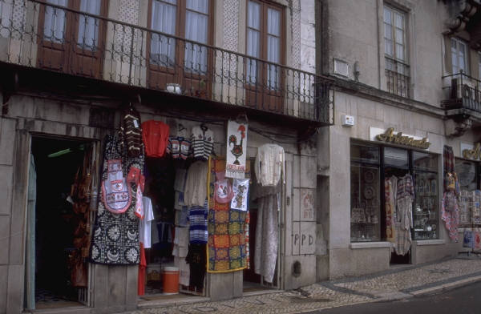

Bargaining
Bargaining Serbian SOLT 1
Objectives Module 3 Lesson 7

During this lesson, the students will be able to accomplish Bargaining. Under this Terminal Learning Objective, the students will learn one task: bargain for merchandise. At the end of the lesson, the students will be able to:

- Bargain for merchandise. This task will include:

- Talk about prices of different merchandise
- Discuss acceptable bargaining techniques
- Negotiate the price in a store

Bargaining Serbian SOLT 1
Introduction Module 3 Lesson 7

Serbia and Montenegro offer a wide variety of shopping opportunities: department stores, duty-free shops, and outdoor markets. Many of the subway stations and bus terminals have underground shopping with an abundancet of merchandise. Bargaining is a common thing when buying merchandise at the outdoor markets, but bargaining in government or private stores is not common. As a foreigner you could be paying three times more than what the merchandise is really worth. Therefore, knowing some bargaining techniques is of great importance.

Tip of the day
There are two groups of sellers in the open-air markets: шверцери (препродавци) (black marketers) and трговци (merchants).

Exercise 1
Read the following text about the flea market and answer with true or false.
Људи често одлазе на бувљу пијацу. Бувља пијаца или бувљак је увек претрпан са трговцима старудија, шверцерима и обичним људима. Обични људи долазе да купе робу по нижој цени или само да разгледају ствари на тезгама. Понуда је широка: стари намештај, бицикли, играчке, накит, књиге, кућански апарати, музичка опрема, алатке, инструменти. Купци се обично погађају са трговцима за цену. Тако могу да уштеде пар динара.

претрпан са (crowded with)
трговци старудија (junk dealers)
обични људи (ordinary people)
роба (merchandise)
разгледати (to browse; to view)
тезга (counter)
накит (jewelry)
погађати се (to bargain)
уштедети (to save money)
купци (buyers)
бувља пијаца (бувљак)

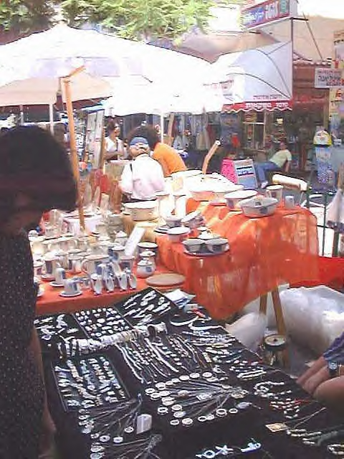

© Ruth Heiges, 2000

Bargaining Serbian SOLT 1
Introduction Module 3 Lesson 7

Exercise 1 (continued)

T F

1. На бувљој пијаци можете да се погађате за цену. _____ _____

2. Људи не иду често на бувљак. _____ _____

3. Купци купују робу по вишој цени на бувљаку. _____ _____

4. На бувљаку можете да уштедите новац. _____ _____

Exercise 2
Marko is shopping today at the flea market. There are two situations that the instructor will read. Be careful! This is a very colloquial Serbian so listen as many times as you need. After listening answer the questions written below.

Situation 1 Situation 2

М. Кол’ко су ти фармерке? М. Кол’ко ти је камера?
Т. 250. Т. 500 динара. Права ствар, увоз
М. Превише. из Немачке.
Т. Кол’ко би ти дао? М. Може за 400 динара?
M. 150. Т. 480?
T. Ух, што си леп. М. 400 или не купујем
М. Ено онај тамо продаје за 150 динара. Т. 450?
Т. А ти иди код њега па купи. М. Не може.

Т. Еј бре што си чудан. Нек ти

буде 400.

ко’лко (колико)
бре (colloq.)
чудан (strange)
права ствар (right stuff)

Bargaining Serbian SOLT 1
Introduction Module 3 Lesson 7

Exercise 2 (continued)

- What did Marko want to buy?
- What did he buy?
- Which of the two merchants was willing to negotiate?
- How would you describe the merchant in situation 1?
- What was the original price of the merchandise in situation 2?
- How much did Marko pay at the end?

Exercise 3
Read the advertisements below and answer the questions.
Мушке кошуље и одела по ниским ценама на бувљаку код железничке станице
Антиквитети и зидни часовници (233-2556)
Женске чарапе из Италије, пијаца на Зеленом венцу
Техничка роба из Немачке
(345-7789)
дечија обућа и одећа/ потпуно ново (816-555)
стари намештај, пијаца на Вождовцу

- Which of the merchandise mentioned can be bought at an open-air market and why?

- Where can one buy ladies’ socks?

- What could be bought close to the railway station?

- What is offered on the market in Vozdovac?

Bargaining Serbian SOLT 1
Introduction Module 3 Lesson 7

Exercise 4
Students work in pairs. You are at the flea market and want to buy the items below. Go to the counter and ask for the price of the merchandise. Bargain with the merchant (your partner).

Expressions

Да ли има нешто по нижој цени? | Is there anything at a lower price?
То је превише (скупо). | That’s too much.
Oдакле је ова роба? | From where is this merchandise?
Где си набавио/набавила робу? | Where did you get this merchandise?
Ти си ме преварио/преварила. | You ripped me off.
Наплатио/наплатила си ми више. | You charged me more.
Хоћу назад мој новац. | I want my money back.
Роба је лошег квалитета. | The merchandise is of poor quality.
Од чега је направљен/а/о? | What is it made of?
Нисам заинтересован/заинтересована. | I am not interested.

Bargaining Serbian SOLT 1
Grammar Notes Module 3 Lesson 7

Reflexive Verbs

Verbs of which the action passes back to the performer are called reflexive verbs. The subject of such verbs is the short form of the reflexive pronoun себе (short form се) in the Accusative case.

Examples:

Деца се играју напољу. Children are playing outside.
Он се погађа око цене. He is bargaining the price.
Ми се радујемо посети. We are looking forward to the visit.
Они се венчавају у петак. They are getting married on Friday.

играти се (to play)

ја се играм ми се играмо
ти се играш ви се играте
он се игра они се играју

Себе (се) through different cases:

The pronoun себе corresponds to the English “oneself, myself, yourself, herself, himself, itself, ourselves, themselves, yourselves,” but also “me, you, him, her, it, us, you, them” if the latter refers directly to the subject of the sentence.

Examples:

Видим себе (се) у огледалу. I see myself in the mirror.
Она је купила себи нову хаљину. She bought a new dress for herself.
Ми носимо наше књиге са собом. We carry our books with us.
Они купују себи нов намештај. They are buying new furniture for
themselves.

Declension

Nominative | -
Genitive | себе
Dative | себи
Accusative | себе, се
Vocative | -
Instrumental | (са) собом

Bargaining Serbian SOLT 1
Grammar Notes Module 3 Lesson 7

*Please remember that there are a few verbs in Serbian that occur only with the reflexive particle се although they don’t have the reflexive meaning.

смејати се (to laugh)
играти се (to play)
чудити се (to wonder)
надати се (to hope)
догодити се (to happen)

Exercise 1
Here are some English questions. Write each question in Serbian. Compare your work with a partner.

- Why don’t you get dressed? (облачити се)
- Are you putting your shoes on? (обувати се)
- Why are you changing? (пресвлачити се)
- Do you wash your face in the morning? (умивати се)
- Do you shave? (бријати се)
- When do you take a shower? (туширати се)

Exercise 2
Answer all of the questions from the previous exercise as if you have already finished the action. Pay attention to how all of the verbs are changing their form. This exercise could be a little harder for you, so don’t hesitate to ask your instructor for help.

- I got dressed. (обући се)
- I put on my shoes. (обути се)
- I changed (a dress). (пресвући се)
- I washed my face. (умити се)
- I shaved. (обријати се)
- I took a shower. (истуширати се)

Bargaining Serbian SOLT 1
Vocabulary Module 3 Lesson 7

бријати се (impf.) обријати се (pf.) | to shave
бувља пијаца | flea market
догађати се (impf.) догодити се (pf.) | to happen
лопов, и | thief
надати се | to hope
накит | jewelry
наплатити | to charge
обични људи | ordinary people
погађати се (impf.) погодити се (pf.) | to bargain
преварант, и | liar
преварити | to rip off (in sale); to cheat
препродавац, и | black marketer
пресвлачити се (impf.) пресвући се (pf.) | to change (dress)
претрпан, а, о | crowded
разгледати | to browse; to view
роба, е | merchandise
смејати се | to laugh
тезга, е | counter
трговац старудија | junk dealer
трговац, и | merchant
туширати се (impf.) истуширати се (pf.) | to take a shower
умивати се (impf.) умити се (pf.) | to wash (face)
уштедети | to save money
ценкати се (colloq.) | to bargain
чудан, а, о | strange
чудити се | to wonder
шверцер, и | black marketer

Bargaining Serbian SOLT 1
Culture Notes Module 3 Lesson 7

The Flea-Market in the FR of Yugoslavia
When shopping at the open-air market in the FR of Yugoslavia, don’t be surprised if you notice that some merchandise doesn’t have price tags. Be aware that a few merchants can have the same product with different prices, so take time and compare the prices before you decide to buy something.
You can bargain in small stores where the sales associate is the owner, or where the owner of the store is at least present. You don’t bargain in big stores where employees are the sales associates. Many people, especially these days, tend to go to бувљак to buy what they need, because they can’t afford the high prices in the regular stores. On бувљак you can find everything from home-made things, jumpers and tablecloths, to service parts for all kind of domestic appliances. Бувљак is located outside the city limits and close to the residential areas (see the picture below).
Bargaining is very common at this type of market. In any big city you can also see small markets with a few vendors selling food and basic necessities near a metro station or a bus stop. This is very convenient for most people since they don't have to make a special trip to the store. People can buy things they need on the way home from work.
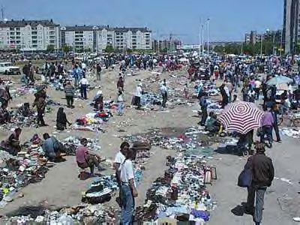

© BeoCITY (Beogradski buvljak)

Bargaining Serbian SOLT 1
Application Activities Module 3 Lesson 7

Activity 1
Students work in pairs. You are at the flea market. Your partner is one of the merchants. Make up the dialog using the instructions given below.

You Your partner

Ask for the price of a sofa. Say the price (1500 DIN)
Ask what material the sofa is made of. Say that the sofa is made of leather.
Say that this is not all leather. Say that it is.
Say that you will pay only 700 dinars. Say that it is not enough and repeat
that the sofa is made of leather.
Say that you are not interested. Make an offer of 900.
Say no. Say 850.
Offer 750. Accept it.

Activity 2
Circulate around the room and interview each other asking questions written below. The questions are related to the shopping at a flea market. After the interview, report to the class the information that you’ve gotten from one of your classmates.

- Где обично купујеш одећу, у продавници или на бувљаку?
- Зашто?
- Где купујеш ствари за кућу?
- Колико можеш да уштедиш месечно ако купујеш (if you are buying) робу на бувљаку?
Белешке (Notes):

Bargaining Serbian SOLT 1
Application Activities Module 3 Lesson 7

Activity 3
Read the following customers’ complaints about some dealers and answer the questions.

Customer 1 Customer 2

В... је преварио више него једног човека. Такође и мене.

Чекао сам два месеца да добијем пакет. Он и није тако лош трговац али робу морате да чекате веома дуго, понекад и три до четири месеца.

Customer 3
М.... је преварио многе људе. Он обично каже да има робу прве класе али његова роба не вреди ништа. Он је прави лопов и преварант. Ја ћу да га пријавим полицији.

Customer 4
Мој савет је: Немој да имаш посла са лоповом.

- Which of the four customers is most upset?

- Which customer is talking in favor of the dealer?

- What advice does customer 4 give to the other customers?

- What does customer 3 think about the merchandise offered from a particular dealer?

- What is wrong with the merchandise that customer 2 is talking about?

Bargaining Serbian SOLT 1
Application Activities Module 3 Lesson 7

Activity 4
Look at the front page of the magazine Суботичке пијаце (the markets of the city of Subotica) and answer the questions.
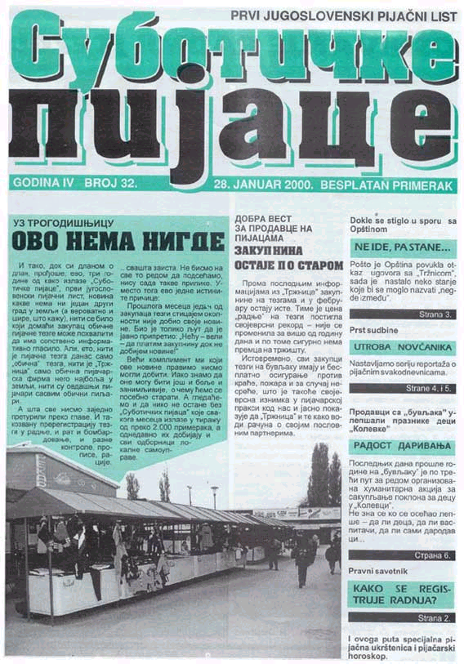

Bargaining Serbian SOLT 1
Application Activities Module 3 Lesson 7

Activity 4 (continued)

- What do you notice regarding the alphabet?
- How many years has this magazine been published?
- When was this issue published?
- Find the Serbian equivalent for the English expression “The First Yugoslav Market Paper.”
- On which page can you read about the shop registration?

Activity 5
The following conversation takes place at the flea market. But something is wrong with the sentences. They are not in the right order. Read the sentences and number them in an order so that the conversation makes sense.

Не могу да ти дам јефтиније.
Колико ти је овај сервис?
Прави порцелан из Кине.
850 динара.
Ја ћу да ти дам 600 динара.
То је превише скупо за мене.
Какав је то сервис?
600 је премало. Може 650?

Activity 6
Students work in pairs. Milan came home from the open-air market. He and Monika are having an argument. Play this role with your partner and decide if the answers are true or false.

Моника: Милане, зашто си купио сланину? (bacon) Колико си је платио?
Милан: 25 динара.
Моника: 25 динара? Рекла сам ти да је сланина скупа.
Милан: Али ја волим сланину.
Моника: Написала сам ти шта да купиш. Не можемо да трошимо превише на храну.
Милан: Ја купујем шта ми се допада.
Моника: Следећи пут ја идем да купујем. Ти само трошиш паре.

Bargaining Serbian SOLT 1
Application Activities Module 3 Lesson 7

Activity 6 (continued)

T F

1. Милан је ишао на тржницу. _____ _____

2. Милан је купио сланину и платио је 18 динара. _____ _____

3. Милан воли сланину. _____ _____

4. Моника је веома весела. _____ _____

5. Следећи пут Моника неће да иде да купује. _____ _____

Activity 7
Students work with the same partner from the previous activity. This time Monika came back from the open-air market. Milan wants to know what she bought. Practice with your partner. Form questions and answers using the following items.

Example: (хлеб - 2)
Да ли си купила хлеб?
Да, купила сам два хлеба.

Млеко – 1 литар месо – ½ кг. телетине

Сир – ½ килограма детерџент – 1 кутију

Воће – 1 килограм новине – (negative answer)

Парадајз – (negative answer)

Bargaining Serbian SOLT 1
Skill Enhancement Activities Module 3 Lesson 7

Activity 1
Listen to the instructor read the following short conversations and identify the store in which each takes place. (тржница, бувља пијаца, робна кућа, самопослуга)

1.________________________________ 2.________________________________

3.________________________________ 4.________________________________

Activity 2
Listen to the instructor read the conversation between a customer and a merchant. You will probably not understand everything in detail; listen for the general context. Answer the questions below.

What was bought?
For whom?
The original price?
The final price?

Activity 3
Read the text below and find the answers to the questions. Again, look for the general context since some of the sentence structures are not familiar to you.

Пре него што идете на тржницу проверите шта имате у кући. Немојте куповати што вам не треба. Немојте да купујете храну кад сте гладни. Потрошићете много новаца.
На бувљој пијаци ће вас свако преварити. Добро погледајте робу и цену. Немојте куповати одмах од првог трговца. Разгледајте тезге. Увек се погађајте за цену. Тако можете да уштедите новац.

1. What is this text about?
________________________________________________________________________

2. What shouldn’t you do when going grocery shopping?
________________________________________________________________________

Bargaining Serbian SOLT 1
Skill Enhancement Activities Module 3 Lesson 7

3. According to the text, everybody at the flea market will try to rip you off, kiss you, hit you. What is the right answer?
________________________________________________________________________

4. What should you not do at the flea market?
________________________________________________________________________

5. What should you do at the flea market?
_______________________________________________________________________

Activity 4
Vesna is shopping today. Listen to the instructor read her conversation, and then find the right answer to the questions.

1. What kind of clothing is Vesna looking for?

- she wants a dress that she can wear at work
- she wants a dress for going out with her boyfriend
- she wants a tennis shirt
- she wants a casual shirt
- she wants something light for the summer

2. What size does Vesna wear?

- 38
- 39
- 42
- 40
- 36

3. Why didn’t Vesna buy the merchandise?

- It was too expensive.
- It was too big.
- It was made of silk and she didn’t like silk
- She didn’t like the color.
- The merchant was not very friendly.

Bargaining Serbian SOLT 1
Skill Enhancement Activities Module 3 Lesson 7

Activity 5
Look at the excerpts from the advertisements and answer the questions below. The ads are written in the Roman alphabet and in the ijekavian dialect.

1. 2.
Mladic, 22 godine, zaposlen, stambeno situiran, sarmantan i zgodan bi zelio upoznati djevojku od 20 do 24 godine.
Kupujem kamp prikolicu do pet godina staru.

3.
Molim sve one koji bilo sta znaju o mojoj prijateljici, Suljanovic Sabini, iz Sarajeva da mi jave. Cula sam da je u Austriji.

4. 5.
PRODAJEM RENAULT 5 GT 1995GOD. CRNa boja, u odlicnom stanju.
Izdajem prostor od 400 m2 Moze kao poslovni prostor, kafic ili klub.

1. One of these ads is a lost connections ad. Find the ad, tell its number, the name of the searched person and the relationship to the person who is looking for her.

2. If you are looking for a business space, which of the ads would be the most suitable for you?

3. The young man in ad number 2 is looking for a woman. Name two attributes that he uses to describe himself.

4. What is offered in ad number 4?

Bargaining Serbian SOLT 1
Skill Enhancement Activities Module 3 Lesson 7

Activity 6
Complete these sentences with the most appropriate words from the jumble box.

1. Понуда на ______________ је широка и разноврсна.

2. _________ са трговцима је веома често.

3. Морате да пазите да вас не _____________ и не узму новац.

4. Трговци увек хоће да продају робу по вишој ______________.

5. Морате да добро отворите __________ и разгледате робу.

цени бувљаку очи преваре ценкање

Bargaining Serbian SOLT 1
Skill Enhancement Activities Module 3 Lesson 7

Activity 7
Write down what each of the men is saying about their products. Write at least three sentences. Use your dictionary to make their announcements more interesting. The instructor will check all assignments in the class and choose which student wrote the most interesting announcement.

________________________________________________________________________________________________________________________________________________________________________________________________________________________

________________________________________________________________________________________________________________________________________________
________________________________________________________________________________________________________________________________________________________________________________________________________________________________________________________________________________________________
____________________________________________________________________________________________________________________________________________________________________________________________________________________________________________________________

Bargaining Serbian SOLT 1
Homework Module 3 Lesson 7

Activity 1
You want to spend a vacation on the Adriatic Sea and you want to know the prices in the food markets there. Listen to the announcement and write down the prices next to the products.

млеко ____________ конзервирано воће и поврће ______________

кромпир _________ уље _________________

чоколада __________ грашак ______________

Activity 2
Complete the sentences using the reflexive pronoun себе.

1. Зашто не купиш _________ ново ауто, Мирко?

2. Они су набавили _________ шофера.

3. Није желео да види _________ у гужви.

4. Разговарала је сама са ______________.

5. Да ли сте наручили _____________ ручак?

Bargaining Serbian SOLT 1
Homework Module 3 Lesson 7

Activity 3
Read the following shopping announcement and do the exercises that follow. Look for the general context.

Следећи месец, дакле у децембру, имаћемо велико снижење цена. Новогодишњи празници су ту па зашто да се не купи нешто лепо и повољно. Наши продавци ће бити сретни да вам помогну. Наш ресторан ће радити цели дан. Ту ћете моћи да добијете бесплатну кафу и дезерт. Предвиђамо да ће цене бити снижене и до 50%.

The words in the box below are all related to shopping activities and they are also synonyms. Find the synonym pairs among the words and write them together.
продавац коштати набавити

ценкати се трговац цена
купити погађати се

__________________________
__________________________
__________________________
__________________________
__________________________

Activity 4
According to the announcement, in which month do they have this sale? What benefit is also offered during the sale?

