SOLT Serbian Module 4 Lesson 3

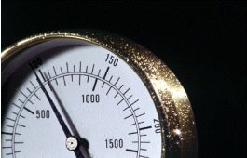

Location and Directions
Location and Directions Serbian SOLT 1
Objectives Module 4 Lesson 3

During this lesson, the students will learn about location and directions. Under this Terminal Learning Objective, the students will learn three tasks: identify the compass directions, give directions in the field, in town, in a building, and give information regarding location. At the end of the lesson, the students will be able to:

- Identify the compass directions. This task will include:

- Tell cardinal points on the compass
- Name directions in the TL
- Provide information on how to get to a certain place
- Use the vocabulary items for compass directions, such as north, south, east, and west
- Explain degrees, mils, azimuth, and grid coordinates when using a compass

- Give directions in the field, in town, in a building. This task will include:

- Request directions in a building
- Provide directions in a building
- Request directions in town
- Provide directions in town
- Request directions in the field
- Provide directions in the field
- Provide distance in meters using a map

- Give information regarding location. This task will include:

- Ask and provide information on how to get to certain location
- Discuss about the difference between polar and magnet north
- Provide reference points
- Describe reference points
- Describe natural and man-made features

Location and Directions Serbian SOLT 1
Introduction Module 4 Lesson 3

Getting lost in a foreign country can happen to anyone, so it is necessary to learn how to describe the surroundings in the target language, to know and understand the compass directions, to be able to read the street maps or to recognize land marks and building structures.

Tip of the day
Према компасу ФР Југославија се налази у југоисточном делу Европе. – According to the compass, Yugoslavia is located in the southeastern part of Europe.

Стране света (Cardinal Points)

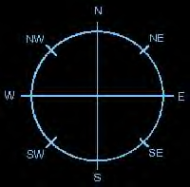
Север

северозапад североисток

Запад Исток

југозапад
југоисток

Југ

Где?

Нови Сад се налази на северу Југославије. Novi Sad is located in North
of Yugoslavia.
Нови Сад се налази у северном делу Југославије. Novi Sad is located in the
northern part of Yugoslavia.
Нови Сад се налази северно од Београда. Novi Sad is located north
from Belgrade.
Location and Directions Serbian SOLT 1
Introduction Module 4 Lesson 3

Exercise 1
Practice with your partner. Use the examples given on the previous page and ask each other questions about the location of other Yugoslav cities according to the map below. Please, use all three versions for your answers.

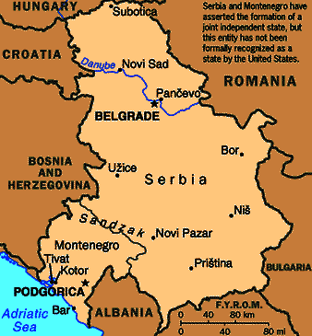

Exercise 2
Look at the map of the Federal Republic of Yugoslavia again and ask questions according to the example below. Use the following cities: Subotica, Novi Sad, Užice, Priština, Bar. Choose only one way of transportation.

from - to
Example: Како можемо да дођемо из Београда до Новог Сада?
Из Београда до Новог Сада можете да дођете
аутом/аутобусом/возом/авионом.

Location and Directions Serbian SOLT 1
Introduction Module 4 Lesson 3

Координатна мрежа (Grid coordinates)

*The logic of the grid coordinates on Yugoslav topographic maps is similar to that of American or any other maps.

Exercise 3
Below is the table of geographical coordinates of some Yugoslav cities. Study the map and answer the questions.

ГЕОГРАФСКЕ КООРДИНАТЕ
(GEOGRAPHICAL COORDINATES)

 | Северна географска ширина  (North geographical latitude) | Источна географска дужина  (East geographical longitude) | Место | Ваздушна удаљеност према географској ширини и дужини  (Areal distance)

степени
(degrees)
Север | 45°16'30" | 14°36'00" | Д......... | 2°43'30"
Југ | 42°33'00" | 16°07'00" | Т.........
Исток | 44°03'00" | 17°17'30" | М...... | 3°53'30"
Запад | 44°56'00" | 13°24'00" | С.....

- На којој географској ширини се налази град Д...?

- На којој географској дужини се налази град С...?

- Колика је ваздушна удаљеност града М...?

Location and Directions Serbian SOLT 1
Introduction Module 4 Lesson 3

Tip of the day
When asking about a direction in town or for a building, always use Ви (polite form).

Извините, где се налази банка?

Банка
Аутобуска станица

право

лево (на лево)
Ресторан

‘Златибор’
десно(на десно)

1. Извините, како да дођем до банке? Идите право, друга улица
десно.

2. Извините, где се налази ресторан Златибор? Само идите право и скрените
лево.

3. Извините, да ли је аутобуска станица лево Није ни лево ни десно. Идите
или десно? право. Аутобуска станица је на
крају улице.

Exercise 4
Listen to the instructor read all three situations written above. Try to figure out the meaning of the words in bold. Underline all the words that indicate direction.

Location and Directions Serbian SOLT 1
Introduction Module 4 Lesson 3

Exercise 5
Now it is your turn to find your way to certain buildings. Draw a simple map according to the directions given below. Compare your drawing with your partner.
Without looking at the written directions, say where each building is located.

Идите право и скрените десно. Пошта је на десној страни.
Скрените овде лево. Биоскоп је одмах иза угла.
Идите право. На трећој улици скрените десно, онда право. Ресторан је на крају улице.

Exercise 6
Colonel Petrovic is in the military command building, but he doesn’t know where a certain office is located. He asks the secretary Ms. Simic. Listen to the instructor read the conversation and decide if the statements are true or false.

T F

1. Colonel Petrovic is looking for a laundry room. _____ _____

2. He receives the instructions to go to the second floor. _____ _____

3. The place he is looking for is at the end of
the hallway. _____ _____

4. The place he is looking for is on the left hand
side. _____ _____
Location and Directions Serbian SOLT 1
Introduction Module 4 Lesson 3

Tip of the day

There are three expressions that you need to remember when being in the military or any other field: Опасност! (danger), Не прилази! or Приступ забрањен! (Do not approach/Do not enter!), Минско поље! (mine field)

Раскрсница (Intersection)

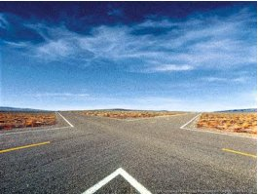

Exercise 7
Marko is visiting the countryside of Serbia. He asks a passerby to give him certain directions. Read the text below and correct the statements written in English.

Марко: Извините, залутао сам. Како да нађем пут за Београд?
Пролазник: Возите право до следеће раскрснице. На раскрсници скрените лево.
Марко: И онда?
Пролазник: Возите право, отприлике 2-3 километра. Са десне стране ћете видети бензинску пумпу. Код бензинске пумпе скрените десно. Одатле до аутопута за Београд има 1 километар.
Марко: Хвала
Пролазник: Нема на чему. Следећи пут немојте ићи без мапе.

1. Marko is asking for the nearest bakery.
2. He should drive until he reaches the second intersection.
3. At the intersection he should turn right.
4. He should drive until he reaches the military base.
5. He will reach the highway after 3 kilometers.
6. Next time, Marko should not go on a trip without first learning Serbian.

Location and Directions Serbian SOLT 1
Introduction Module 4 Lesson 3

Exercise 8

Students work in pairs. Draw a map of the location from the previous exercise. Make up a similar dialog but now ask for directions from the destination to the starting point. Name your starting point село (village).

Полазиште (Starting point)

Одредиште (Destination)

Expressions
Како да дођем до поште? | How to reach the post?
Колико километара има до Београда? | How many kilometers are there to Belgrade?
Жао ми је али не знам. Питајте милицинера (полицајца). | I am sorry but I don’t know. Ask the policeman.
Да ли је банка у близини? | Is the bank closed?
Да, следећа улица лево. | Yes, the next street left.

Location and Directions Serbian SOLT 1
Grammar Notes Module 4 Lesson 3

Adjectives and Cases

We use adjectives to enrich the sentences, to give them the color. Adjectives are used to describe people, things and places. The adjectives in Serbian agree with the noun in case, number and gender. There are two forms of adjectives: adjectives with indefinite meaning and adjectives with definite meaning.

Example:

Indefinite-Serbian Indefinite-English

Ово је стар човек. This is an old man.

Definite-Serbian Definite-English

Стари човек је уморан. The old man is tired.

Please note that only masculine adjectives in Nominative singular make this distinction between the indefinite and the definite form by using the ending – i. The feminine and neuter adjectives don’t show any difference regarding the indefinite and definite meaning. The adjectives with definite meaning are used more frequently.

The Nominative and Dative Endings of Definite Adjectives

Singular Plural
M F N M F N
Nominative: лепи човек лепа жена лепо дете лепи људи лепе жене лепа деца

Dative: лепом човеку лепој жени лепом детету лепим људима лепим женама лепој деци

*Note: If the adjective ends in ш, ћ, ђ, ј, the neuter adjectives will have the ending –e in the singular instead of the ending –o.

(лош – bad)

лоше понашање – bad behavior instead of лошо понашање

Location and Directions Serbian SOLT 1
Grammar Notes Module 4 Lesson 3

Exercise 1
Fill in the sentences with the adjectives in parenthesis. Pay attention to the cases and endings.

1. На столу се налази једна ______, _______ књига. (стар, интересантан)

2. На ________ страни реке је чамац. (десни)

3. У _________ граду на обали мора живели су наши родитељи. (мали)

4. Наши ________ пријатељи су нас посетили јуче. (добар)

5. Лепо ти стоје _______ панталоне, ________ кошуља (црн, плав, таман)
и ________ кравата.

6. На __________ делу Југославије је хладније него (северни, јужни)
на __________ делу.

7. __________ људима треба помоћи. (добар)

8. Црква се налази у _________ ________ улици у (мали, тих)
близини градске тржнице.

9. Ова ______ _______ торба је припадала мојој баки. (стар, кожни)

10.__________ део земље је имао много кише. (западни)

Location and Directions Serbian SOLT 1
Vocabulary Module 4 Lesson 3

азимут | azimuth
без (prep. with Genitive) | without
безбедност, и | safety
географска дужина, е | geographical longitude
географска координата, е | geographical coordinate
географска ширина, е | geographical latitude
залазак сунца | sunset
залутати | to get lost, go astray
из - до | from – to
изгубити се | to get lost
излазак сунца | sunrise
југозапад | southwest
југоисток | southeast
канцеларија, е | office
код (prep. with Genitive) | at, on
компас, и | compass
координатна мрежа, е | grid coordinate
кроз (prep. with Accusative) | through
мапа, е | map
наставити | to continue
ни – ни | neither – nor
одатле | from there
одредиште, а | destination
подземна железница, е | subway, s
полазиште, а | starting point
правац, правци | direction
прелазити (imp.) прећи (pf.) | to cross
промашити | to miss something
раскрсница, е | intersection
северозапад | northwest
североисток | northeast
скренути | to turn to
следећи, а, е | next
степен, и | degree
стране света | cardinal points
угао, углови | corner
удаљеност | distance
ходник, ходници | hallway

Location and Directions Serbian SOLT 1
Culture Notes Module 4 Lesson 3

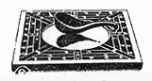

The magnetic compass is an old Chinese invention. The oldest picture of a magnetic compass dates back to 200 B.C. The Chinese used the compass with a rectangular table, having the edges marked with the cardinal directions and constellations.
The needle was a small spoon made of magnetic iron ore. When the spoon was placed on the table, it turned so that the handle pointed south.
Until this century, field compasses had always been dry-card compasses where the magnetic needle moved rapidly and erratically. A major invention, the filling of the capsule with oil, made the needle steady and easy to read.
High quality materials, tungsten steel needles, and jeweled bearings ensure that modern compasses are accurate and reliable.

Location and Directions Serbian SOLT 1
Application Activities Module 4 Lesson 3

Activity 1
Your partner and you are discussing the route that each of you is taking every day to come to work. Use the statements given below and provide the information in Serbian.

You Your partner

Say that you go to work by car. Say that you go to work by bus.
You leave your house at 7 AM. You leave your house at 6:30 AM.
You drive straight to the first You are waiting for bus No.15.
intersection. The bus goes left on the next first street.
At the intersection you turn right. Then it goes straight and then right.
You drive straight and again turn It goes until the next intersection.
right. It turns right and then left again.
Your building is just across the Your building is next to MacDonalds
bank. restaurant.

Activity 2
According to the information from the previous activity, draw a map of the route your partner takes to come to work.

MАПА

Location and Directions Serbian SOLT 1
Application Activities Module 4 Lesson 3

Activity 3
Beogradski sajam (Belgrade Fair)
You and your partner are visiting the Belgrade Fair. Use the example below to ask each other questions about where certain buildings are located.

Example: Где је банка?
Банка је код хале број 5.

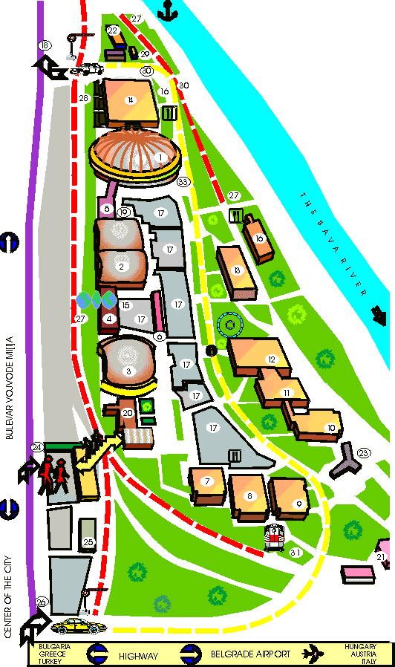

1-14 HALE 1-14 (Halls)
15. WORLD TRADE CENTER
16. RESTORAN
17. OTVORENI IZLOZBENI ......PROSTOR
18. IZLAZ
19. POSTA, BANKA I
......TURISTICKA
AGENCIJA
20. ZGRADA
......BEOGRADSKOG SAJMA
......I RECEPCIJA
21. SAJAMSKI MAGACINI
22. CARINSKI MAGACINI
23. STUDIO RTS
24. ULAZ
25. BLAGAJNA I INFORMACIJE
26. DRUGI ULAZ
27. INDUSTRIJSKI KOLOSEK
28. SPEDITERSKA SLUZBA
29. CARINSKA SLUZBA
30. AMBULANTA
31. ZELEZNICKA RAMPA

you and your
partner
are here (Activity 4)

Location and Directions Serbian SOLT 1
Application Activities Module 4 Lesson 3

Activity 4
Your partner is a tourist visiting the Belgrade Fair. You are working at the Fair helping people find their way around. Use the example below to give directions to certain buildings. Pay attention to the starting point marked on the map in Activity 3.

Example: Како да дођем до банке?
Идите право до краја и скрените лево. Наставите (continue) право
и скрените опет лево. Банка је код хале 5.

Activity 5
According to the map, decide if the statements are true or false.

T F

1. Ресторан се налази прекопута реке Саве. _____ _____

2. Радио – Телевизија Србије се налази на броју 18. _____ _____

3. Улаз је на западној страни мапе. _____ _____

4. Амбуланта је на источној страни. _____ _____

5. Информације се налазе на улазу у сајам. _____ _____

6. Центар града је јужно од Београдског сајма. _____ _____

Location and Directions Serbian SOLT 1
Application Activities Module 4 Lesson 3

Activity 6
In this activity you will be asked to perform 6 tasks. Your partner will play 6 different persons who will help you with all that you need. Your instructor will supervise this activity.
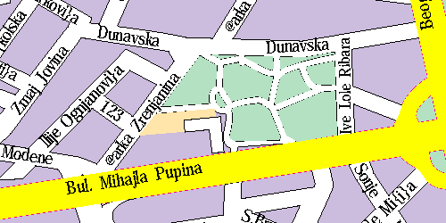
Banka Autobuska stanica

Ti si ovde
Hotel

1. Go to the hotel and book a room for three nights. Ask for the room with the city view.
Ask for the price and whether you can pay by credit card. Explain how you reached the
hotel referring to your starting point. (Your starting point will change from task to
task)

2. Ask the policeman how to reach the bank.

3. Go to the bank and exchange $100 for dinars.

4. Ask someone for the nearest post office. Put the mark on the map.

5. Go to the post office and send two letters by regular mail to Washington. Ask for the
postage price.

6. Find out where the bus station is located. Repeat aloud directions to the bus station.

Location and Directions Serbian SOLT 1
Application Activities Module 4 Lesson 3

Activity 7
Look at the map of Europe and talk about how to reach different destinations. Use the example given below. You can also ask your own questions.

Example: Како се долази од Румуније до Аустрије?
Од Румуније до Аустрије се долази авионом,
аутобусом или аутом.
Које земље треба прећи (to cross)?
Треба прећи Мађарску.

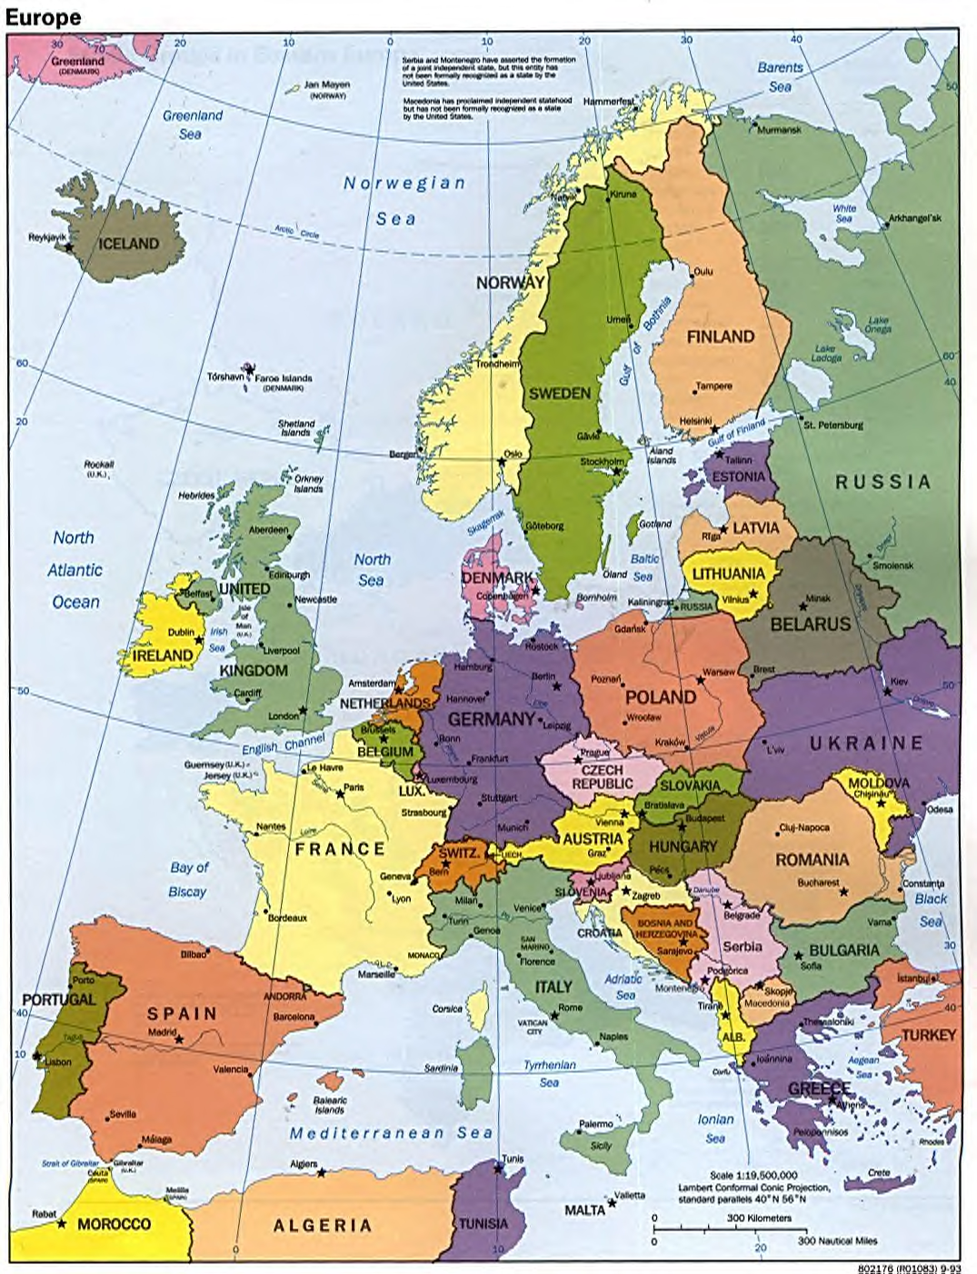

Location and Directions Serbian SOLT 1
Application Activities Module 4 Lesson 3

Activity 8
Imagine that your car got stuck somewhere. Phone your partner (pretend you have a cellular phone) and describe to him/her your whereabouts. He/she should draw a line over the map according to your instructions in order to find you. Reverse the roles.
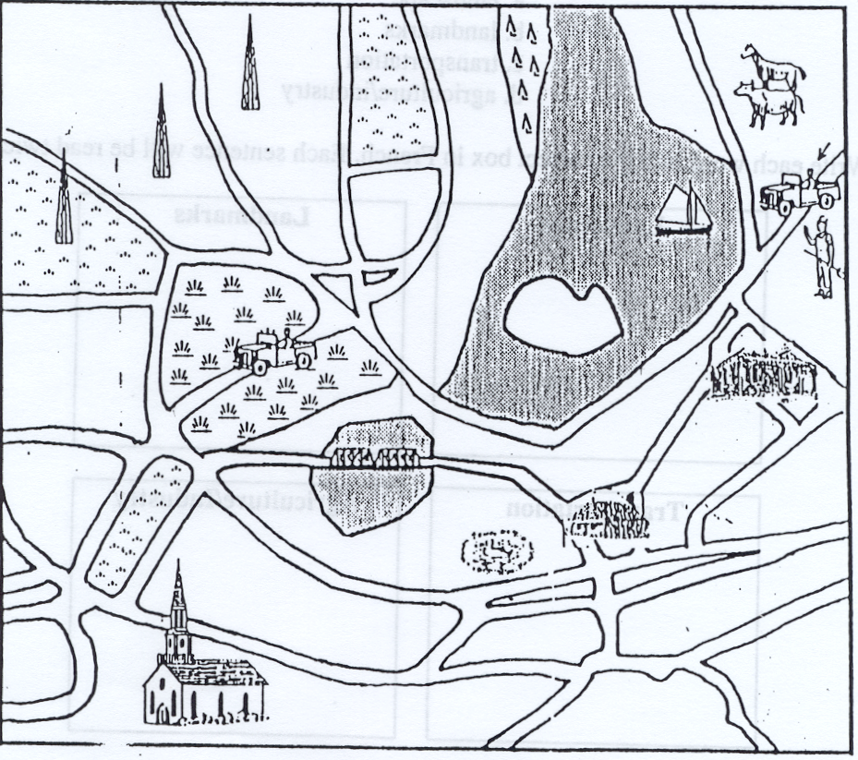

Activity 9
Recently you have traveled to Yugoslavia. The images below show your travel route and the way you have traveled. Use the images to describe the route to your instructor.

10:00 PM 11:00AM 15:00 PM 20:00 PM
Los Angeles Frankfurt (Germany) Budapest (Hungary) Belgrade

Location and Directions Serbian SOLT 1
Application Activities Module 4 Lesson 3

Activity 10
For this activity you will need the US road map. Below are incomplete driving directions from San Diego to Las Vegas. The instructions contain two mistakes.

- Compare the instructions with the map in front of you and find out where the mistakes are.
- Complete the instructions. Compare your work with a partner.

Возите до I-8 Исток, број излаза 115 према Фениксу. Возите право до Аризона-85
Југ. Узмите I-10 Исток према Фениксу. Возите до излаза према Флагстафу. Од Флагстафа возите према северу до Аспена.

Location and Directions Serbian SOLT 1
Skill Enhancement Activities Module 4 Lesson 3

Activity 1
Listen to the conversation between Zoran and Vesna and choose the best answer.

1. Zoran is now in:

a. Belgrade b. Zrenjanin c. Vojvodina

2. Zrenjanin is located:

a. in Rumania b. in southern part of c. in northern part of
of Vojvodina Vojvodina

3. The distance from Belgrade to Zrenjanin is:

a. 650 km b. 640 km c. 660 km

4. Zoran traveled:

a. by train b. by bus c. by car

Activity 2
The following people are asking for different directions in town or in buildings. Listen to the instructor and fill out the information in the table below. Put a checkmark if the conversation is taking place in a building or in a town.

 | Person No. 1 | Person No. 2 | Person No.3 | Person No. 4
Building?
Town?
Looking for?
Where is it?
Location and Directions Serbian SOLT 1
Skill Enhancement Activities Module 4 Lesson 3

Activity 3
Milan got lost somewhere on the road. He asks for directions. After listening to the instructor, answer the questions.

- At what city is Milan asking for directions?
- How many intersections does he need to pass?
- Once he reaches the first intersection, what is he supposed to do?
- How much time does he need to reach his destination?

Activity 4
Your classmate wants to visit you, but he doesn’t know the directions to your home address. Draw a map and write directions step by step. Your starting point should be your classmate’s home address. The instructor will check your work.

Activity 5
Vladimir is spending a few days in one of the cities marked on the map below. He sent a message to his girlfriend about his whereabouts but forgot to say the name of the city. Listen to the instructor and try to figure out where Vladimir is. There are two important clues that he mentions.
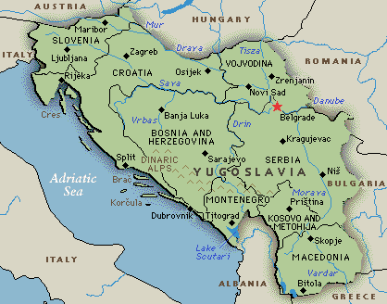

Location and Directions Serbian SOLT 1
Skill Enhancement Activities Module 4 Lesson 3

Activity 6
Read the text below and fill in the blank spaces with the words in the jumble box. For some words you will need to look back at the map from the previous activity.

Град ______ се налази на истоку Србије. Лежи на реци __________. Северно од

њега се налази ____________, а јужно се налази ___________. Град је веома близу

границе са ______________. Његове __________ координате су 43°19' северне

географске ширине и 21°54' источне географске _______ . _________

града је ________ .

Бугарском Ниш географске површина

Приштина Морави Крагујевац дужине

596,71 квадратни километар

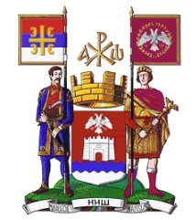
Location and Directions Serbian SOLT 1
Skill Enhancement Activities Module 4 Lesson 3

Activity 7
Look at the map below. Each of your classmates will select a certain point on the map. Walk around the classroom and talk to at least three of your classmates. Ask them where they are located. The starting point is Studio 99. Together determine how to get from the point where they are to Studio 99. Describe one direction in front of the class.

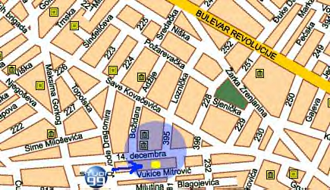

Activity 8

Колико познајете географију?
Close your book and map. Read the statements below and decide if they are true or false. Provide the right answer for the false statements. Compare your work with a partner.

T F
1. Главни град Црне Горе је Приштина. _____ _____

2. Београд лежи на Сави. _____ _____

3. Нови Сад се налази јужно од Београда. _____ _____

4. Косово је у Босни. _____ _____

5. Главни град Босне и Херцеговине је Сарајево. _____ _____
Location and Directions Serbian SOLT 1
Skill Enhancement Activities Module 4 Lesson 3

Activity 8 (continued) T F

6. ФРJ се граничи са Италијом. _____ _____

7. Црна Гора излази на море. _____ _____

8. Србија и Црна Гора су два града. _____ _____

9. Косово је близу Македоније. _____ _____

10.ФРЈ се налази западно од Бугарске. _____ _____

Activity 9
Шта траже?
Complete the sentences below according to the image.

1. Марија тражи ___________. 4. Јанко тражи ___________.

2. Ја тражим _________. 5. Мира тражи ___________.

3. Они траже 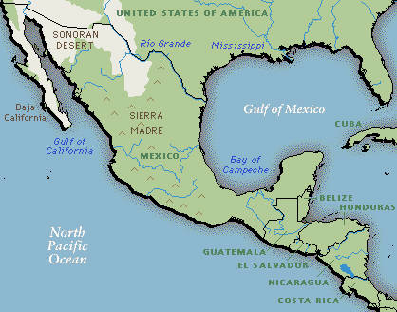 _________. 6. Ми тражимо ___________.

Location and Directions Serbian SOLT 1
Homework Module 4 Lesson 3

Activity 1
Listen to the dialogue between Mirko and Slavica related to the geography and complete the unfinished sentences below.

- Лос Анђелес се налази на _______________ Америке.

- Главни град Аустрије се зове _____________.

- Аустрија се граничи са __________________.

- Рим је главни град ______________________.

Activity 2
Maria is describing the place where her family lives. Read the text and complete the sentences below.

Моја породица живи у Улици Јове Јовановића Змаја. То је одмах поред главне градске тржнице. Моја школа није далеко. Од наше зграде до школе има само један километар. Ја идем у школу пешке а понекад идем градским аутобусом. Моја другарица Светлана живи у Улици 29. новембра. Често се посећујемо. До њене куће ми треба 10 минута. Обично идем право до раскрснице и скренем лево. Идем право и у другој улици скренем десно и ту је Светланина кућа.

1. Maria’s home is close to the: a. city cinema
b. city market

2. From Maria’s home to the a. by foot
school one cannot go: b. by train

3. To reach Svetlana’s house from a. turn left on the intersection
Maria’s one should: b. turn right on the intersection

Location and Directions Serbian SOLT 1
Homework Module 4 Lesson 3

Activity 3
Reviewing verbs.
Put the following verbs in the Present Tense.

1. Како ___________ (звати се – ти)?

2. Моје очи _____ (бити) плаве.

3. Шта волиш да _________ (радити)?

4. Милан иде веома често да ________ (једрити).

5. Шта радо ________ (читати-они)?

6. Да ли често _______ (ићи - ти) да _______ (пливати)?

7. Одакле __________ (долазити) твоји пријатељи?

8. Мирјана радо _________ (свирати) гитару.

Activity 4
Prepositions
Complete the sentences with one of the following prepositions: на, у, кроз, иза, без, код, до. Some prepositions will be used more than once.

1. Они путују _________ Италију.

2. Пошта се налази __________ левој страни улице.

3. Како да дођемо _________ аутобуске станице?

4. Идите _________ раскрснице и скрените _____ леву страну.

5. Она живи _____ Мађарској.

6. Аутобус је паркиран ______ станици.

7. Прођите ______ зграду и изађите _______ другу страну.

8. _______ угла се налази велика самопослуга.

9. Бензинска пумпа је ________ раскрснице.

10.Немој да идеш у продавницу _______ новаца.
Location and Directions Serbian SOLT 1
Homework Module 4 Lesson 3

Activity 5
Listen to Jelena describing the place where she lives and telling directions from her house to the place where she works. Draw a map according to what you hear. Compare your work with a partner the next day.

Activity 6
Write down in Serbian the following directions:

- How to get from your post to New York City.
- How to get from your post to the nearest gas station.

Read the directions the next day in class.

