SOLT Serbian Module 5 Lesson 2

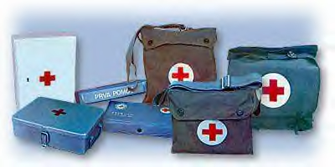

First Aid

First Aid Serbian SOLT 1
Objectives Module 5 Lesson 2

During this lesson, the students will be able to give instructions about First Aid procedures and will be able to communicate about applying first aid and identify items in a first aid kit. At the end of the lesson, the students will be able to:

- Identify items in a first aid kit. This task will include:

- Describe the contents of a first aid kit
- Describe a toiletries bag
- Name items used in giving first aid

- Apply first aid. This task will include:

- Dressing a wound
- Describing first aid procedures
- Describing CPR procedures

First Aid Serbian SOLT 1
Introduction Module 5 Lesson 2

Tip of the day
In the FRY, one can buy medicine only in the Апотека – pharmacy.

*Every year thousands of minor cuts and scratches become infected and result in permanent disability. Keep these facts in mind to avoid infections:
- Take time to get treatment. A few minutes of precaution can save days in the hospitals
- Don’t think that a little cut will not amount to much
- Don’t worry about your name showing up on an accident report
- Never think that just because similar cuts have healed in the past this one will do the same
- Do not use “home remedies” to take care of the problem

Прва помоћ (First Aid)
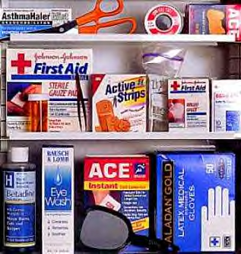

маказе

стерилна газа

пинцета

завој

алкохол

фластер

стерилне рукавице

Exercise 1
Look at the first aid kit and read the Serbian terms for the specific items. Explain what each item used for.

First Aid Serbian SOLT 1
Introduction Module 5 Lesson 2

Exercise 2
Make a list of items you usually have at home in your first aid kit, and compare it with your partner’s list. What is similar and what is different?

Exercise 3
Below is a list of the most common items that can be found in a toiletries bag.

1. Read the items aloud and see how many you can recognize.
2. Find out what your partner usually has in his/her toiletries bag.
Note: the items below are given in the Nominative case.

Example: Шта обично носиш у несесеру?
Носим ......
- четкица за зубе
- шампон
- крема за руке
- колоњска вода
- огледало
- апарат за бријање
- дезодоранс

Tip of the day
One cannot get a drivers license in the FRY before passing the first aid exam.

*When you have to apply first aid to a patient, it is important for you:
- Not to panic and to act with composure
- To have confidence in what you do
- To make the patient trust you
- To take care of yourself, so as not to be infected by any virus while applying mouth –to-mouth artificial respiration

First Aid Serbian SOLT 1
Introduction Module 5 Lesson 2

Exercise 4
Sergeant Markovic was injured during the military training. Sergeant Rakovic is trying to help him. Read their conversation and decide if the statements are true or false.

Незгода

Раковић: Да ли си се повредио? to injure
Марковић: Јесам. Осећам бол у левој нози. pain
Раковић: Да ли можеш да устанеш?
Марковић: Покушаћу. Не могу.
Раковић: Дај ми да погледам. Нога ти је отекла. swollen
Ставићу ти хладан облог. Да ли те јако боли? compress
Марковић: Боли.
Раковић: Идем да зовнем помоћ. Не мрдај! Don’t move!

T F

1. Sergeant Markovic has pain in his left arm. _____ _____

2. He is not able to get up. _____ _____

3. Sergeant Rakovic puts a bandage around Sergeant _____ _____
Markovic’s wound.

4. The help will come in ten minutes. _____ _____

First Aid Serbian SOLT 1
Introduction Module 5 Lesson 2

Exercise 5
Work with a partner. Read the instruction below on how to perform the artificial resuscitation and finish the activities that follow.

Вештачко дисање

- Положите повређеног на леђа и забаците му главу уназад

- Ставите образ близу носа и уста повређеног

- Пратите и послушајте његово дисање

- Ако повређени не дише, стисните му нос и дајте му ваздух на уста

A. Find the meaning of the three underlined words and write their English equivalent.

_______________________

_______________________

_______________________

B. Put a checkmark next to the statements that are true.
1. When giving mouth-to-mouth resuscitation, the patient’s head should be held upright.
2. During the procedure, the patient’s nose should be squeezed tight.
3. This is done with three fingers.
4. Mouth-to-mouth resuscitation takes 18-20 minutes.

First Aid Serbian SOLT 1
Grammar Notes Module 5 Lesson 2

The Passive Participle

The description of the location of the wound requires the accusative case and the preposition у as in the expressions Он је рањен у главу/Он је рањен у руку.

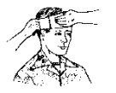
У шта је Мирко рањен?
Рањен је у главу.

The form рањен is the Passive Participle. The Passive Participle acts as an adjective which means it has all three genders (masculine, feminine, neuter) and follows the adjective declension. In Serbian, the passive participle is formed by adding certain endings to the infinitive or to the present tense stem of verbs. There are three groups of endings:

A. Infinitive stem ending in the vowel –a:

Infinitive Passive Participle
Singular: позвати позван, на, но (invited)
Plural: позвати позвани, не, на

B. Infinitive stem ending in a consonant:

Singular: појести поједен, ена, ено (eaten)
Plural: појести поједени, ене, ена

C. Verbs ending in –нути and –ети have these endings:

Singular: смрзнути смрзнут, та, то (frozen)
Plural: смрзнути смрзнути, те, та

Singular: узети узет, та, то (taken)
Plural: узети узети, те, та

First Aid Serbian SOLT 1
Grammar Notes Module 5 Lesson 2

Exercise 1
Information gap activity. The students have two charts: A and B. There is some information missing in each of the charts.
Read the chart listing the names of the wounded soldiers and the body parts that are wounded. Each student has missing pieces of information. For example, partner B finds the name of a soldier without the type of wound that he has on the body part. Partner A has the information. Ask each other questions and provide the answers as in the example below. Be careful! The wounded body parts are given in the Nominative case. You will have to use the preposition “у” and the Accusative case.

Example: B. У шта је рањен Марко Николић?
- Марко Николић је рањен у ногу.

Chart A Chart B
Марко Николић | нога
Славиша Марковић
Ранко Симић | рука
Владимир Костић
Милан Станић | стомак
Бојан Стакић
Мирко Радуловић | глава
Јанко Пашић
Раде Манојловић | пета
Зоран Родић
Марко Николић
Славиша Марковић | обе ноге
Ранко Симић
Владимир Костић | обе руке
Милан Станић
Бојан Стакић | врат
Мирко Радуловић
Јанко Пашић | плућа
Раде Манојловић
Зоран Родић | раме

Impersonal verbs and expressions

The verbs болети (to ache, to hurt), заболети (to start aching), сврбети (to itch), засврбети (to start itching) are used in the 3rd person singular and plural. Look at the examples below:

Examples: Боли ме нога. My leg hurts.
Боле ме ноге. My legs hurt.

Боли га зуб. His tooth hurts.
Боле га зуби. His teeth hurt.

First Aid Serbian SOLT 1
Grammar Notes Module 5 Lesson 2

*Note: As you can see, in English you use the possessive pronoun my, his, etc. whereas in Serbian the accusative case of the personal pronouns (short forms-ме, те, га...) is used. If you want to add the emphasis, you should use the long form of the personal pronouns.

Example: Шта ти је? What’s wrong?
Боли ме глава. My head hurts.

Кога боли глава?
Мене боли глава. (emphasis)

Exercise 2
The people whose names are written below have different problems. Ask each other questions about each person and provide the answers. The clues are given to you. Follow the example:

Example: Шта је Марку? (dative) What’s wrong with Marko?
Боле га руке. His arms hurt.

Јелена – прст
Радмила – стомак
Поручник Симић – око
Капетан Станић – нога
Стефан – зуб
Марко – раме
Мајор Поповић – уши
Владимир - желудац

First Aid Serbian SOLT 1
Vocabulary Module 5 Lesson 2

антибиотик, антибиотици | antibiotic, s
апарат за бријање | shaver
бол, болови | pain, s
болети | to ache, to hurt
вештачко дисање, a | artificial resuscitation
горњи, a, e | upper
гумица, e | rubber band
дезодоранс, и | deodorant
дишни путеви | airway
доњи, а, е | lower
за једнократну употребу | disposable
завој, и | bandage, s
задобити (рану) | to get (wounded)
заштитна маска, е | face shield, s
затезати (impf.) затегнути (pf.) | to tighten
крварење, а | bleeding, s
крварити | to bleed
лабав, а, о | loose
личне ствари | personal belongings
маказе | scissors
маст, и | ointment, s
негде друго | somewhere else
несесер, и | toiletries bag, s
носило, а | stretcher, s
облог, облози | compress
огледало, а | mirror, s
опекотина, е | burn
отечен, а, о (m, f, n) | swollen
пазити (на неког) | to look after someone
паста за зубе | toothpaste
пинцета, е | tweezers
повреда, е | injury, injuries
повредити се | to injure
повређен, а, о | injured
погинути | to get killed
позајмљивати (impf.) позајмити (pf.) | to borrow
покушавати (impf.) покушати (pf.) | to try
посекотина, е | cut, s
посећи се | to cut
прва помоћ | first aid
превијати (impf.) превити (pf.) | to dress (a wound)

First Aid Serbian SOLT 1
Vocabulary Module 5 Lesson 2

прекривати (impf.) прекрити (pf.) | to cover
притиснути | to press
противотров, и | antidote, s
пружати (impf.) пружити (pf.) | to give
рана, е | wound, s
рањен, а, о (m, f, n) | wounded
сврбети | to itch
слепоочница, е | temple, s
сломити | to break
сломљен, а, о | broken
спадати | to belong
стезач, и | tourniquet, s
стерилна газа, е | gauze, s
шприц, еви | syringe, s
штака, е | crutch, s
таблета, е | pill, s
тврда столица/затвор | constipation
удлага, е | splint, s
удови | limbs
фластер, и | band aid, s
цивилна заштита | civil protection
четкица за зубе, е | toothbrush, s
шампон, и | shampoo, s

First Aid Serbian SOLT 1
Culture Notes Module 5 Lesson 2

* One example of the many things people believe in is the UROK (spell, charm) a superstition that attributes to certain people the power of doing children harm just by looking at them. Many charms are put on babies to ward off the spell when they are near one of the persons believed to have the power of the Evil Eye.

Urokljive oči (evil eyes)

Grigory Rasputin

Have you ever heard about Grigory Rasputin? He was one of the most scandalous, influential, mysterious and infamous figure in the history of Russia?
A self proclaimed holy man, Rasputin held the power to heal the sick and predict the future. He had a strong influence over the Tzar’s wife and was known to have had outrageous orgies and drinking binges.
In 1905 Rasputin arrived in St. Petersburg, and in 1907 he met the Tsar and Tsarina. He was needed as a healer for the young heir Alexei who was having a bleeding episode. Alexei’s disease, hemophilia, was common throughout European royalty and was passed on to him by his mother. At first reluctant to invite Rasputin, Nikolai and Alexandra finally realized the extent of their son's affliction and the powerlessness of his doctors. Rasputin began spending a lot of time at the Royal palace, since he was the only one who could relieve the suffering of Alexei. There was a general consensus among officials that Rasputin was negatively influencing Alexandra, and in turn affecting the entire country. He was thought to be a cynical opportunist who used religion to mask his drive for sex, money, and power.
Rasputin is as famous for his death as he is for his life. One evening at a meeting of Russian officials, it was decided that Rasputin was putting the entire nation in danger. Three Russian noblemen took control of the situation. With an intricate plan, the three invited Rasputin over to the Palace on December 30, 1916 to meet the Tsar's beautiful niece. While waiting for her to appear, the men lured Rasputin to the cellar, gave him poisoned wine and his favorite tea cookies which were laced with cyanide of potassium. Rasputin ate all the cookies, finished the wine, but nothing happened. One of the noblemen was dismayed with his lack of initial success and he shot Rasputin. Then he ran up to the living room to report to the other plotters. When he returned to the cellar and leaned over Rasputin’s body the man suddenly rose and tried to strangle him. The “holy man” staggered out into the courtyard where he was shot again. His body was thrown into the Neva River.
There is much controversy over Rasputin’s life, from his mistresses to his mystical healing powers. But what is certain is that he had an irrefutable affect on the Romanov family and the Russian Empire. Shortly before his death, Rasputin wrote a letter to the Tzarina where he predicted: “ … if it was your relatives who brought my death, then no one in your family … will remain alive for more than two years. They will be killed by the Russian people…” His prediction came true.
First Aid Serbian SOLT 1
Application Activities Module 5 Lesson 2

Activity 1
You and your partner are going on a trip. You just realized that you have too many unnecessary items in the toiletries bag. Read the items with your partner and eliminate those that don’t belong to the toiletries bag. Make up a short dialog following the example below.

Example: You: Зашто си ставио/ставила мапу овде?
Your partner: Зато што нам та мапа треба.
You: Мапа не спада овде. Стави је негде друго (somewhere
else).

    - четкица за зубе
    - оловка
    - крема за руке
    - поморанџа
    - апарат за бријање
    - пинцета
    - новине
    - мобилни телефон

Activity 2
Look at the images below and match them with the descriptions.
1. 2. 3. 4.
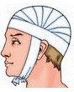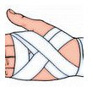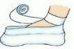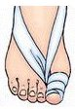

- превијање главе
- превијање стопала
- превијање палца
- превијање руке

First Aid Serbian SOLT 1
Application Activities Module 5 Lesson 2

Activity 3
Read the instructions for emergency techniques in case of bleeding and answer the questions. Refer to the vocabulary list for words that are unfamiliar to you.
- Притиснути рану и ставити преко ње стерилну газу или чисту марамицу. Када се газа или марамица напуне крвљу, преко њих ставити другу газу, марамицу, или чисту мајицу. Важно је да се рана држи стално притиснута тако да се изгуби што мање крви.
- Када крварење престане или успори, замотати рану завојем или крпом.
- Зовнути хитну помоћ.

  - What should you do first to stop the bleeding?
  - What kind of dressing could be used in case of bleeding?
  - How long did it take to care for the wound?
  - Who needs to be called as soon as possible?

Activity 4
The following soldiers have different injuries. Their injuries are shown on the images. Listen carefully to the instructor and match each name that you hear with the image.

1. 2. 3. 4. 5.
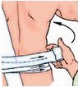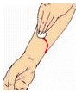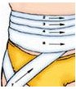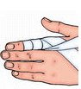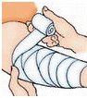

a. Војник Мирковић
b. Војник Петровић
c. Војник Раковић
d. Војник Симић
e. Војник Станић

First Aid Serbian SOLT 1
Application Activities Module 5 Lesson 2

Activity 5
Walk around the classroom and interview your classmates on the topic of injuries. Find out what kind of injuries your classmates have suffered from during their lifetime (it could be light or heavy injuries). Choose one of your classmates and report your findings about his/her injuries to the class. Below are the questions that should be used in the interview and some of the possible injuries. You can also make up the questions of your own.

Повреде
Да ли си икада (ever) био повређен? сломљена рука, нога, прст, ребро...
Какву врсту повреде си имао? рањен у руку, ногу, главу...
Ко ти је пружио прву помоћ? крварење из носа,
Да ли си ишао у болницу?
Колико си остао у болници?

Activity 6
Imagine that you and your partner are sharing quarters while on a joint mission. Each of you has his own toiletries bag. But you suddenly realize that you don’t have some items that you need. Ask your partner if he has them and if he could lend them to you. Then he/she will ask you for some items that he/she needs. How would you react? Follow the example.

Example: Да ли имаш чешаљ?
Имам.
Да ли могу да га позајмим? (borrow)
Изволи. or Жао ми је али не можеш. Не позајмљујем личне ствари.

You: Your partner:
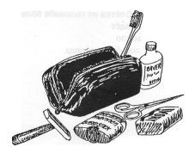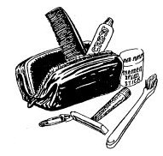
First Aid Serbian SOLT 1
Application Activities Module 5 Lesson 2

Activity 7
You and your partner find yourselves in a situation to give first aid. Different injuries are given below. Treat each injury by saying what items you will use to give first aid.

1. посекотина на прсту (the cut on the finger)
2. посекотина на нози (the cut on the leg)
3. вештачко дисање (CPR procedure)
4. јако крварење (heavy bleeding)

First Aid Serbian SOLT 1
Skill Enhancement Activities Module 5 Lesson 2

Activity 1
Three of you are packing up for a mission. Your Yugoslav friend, Student A, is reading you a list of supplies that you need for your first aid kit. Students B and C, tell him what is still available in your individual kits. Follow the example.

Example: Student A: Да ли имате антибиотике?
Student B: Ја имам два пакета.
Student C: Ја немам.
Student A: Мораћеш да их набавиш or Он ти може позајмити or
Позајми од њега (these are some of the suggestions)

Student A:
- пинцета - таблете
- фластер - рукавице
- крема за опекотине - маказе
- антибиотици - заштитна маска (CPR)
- завој
- стерилна газа

Student B:

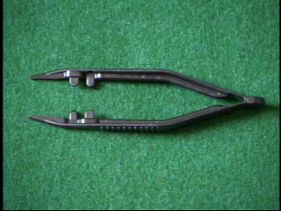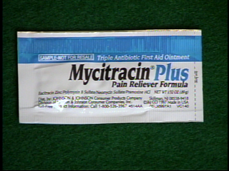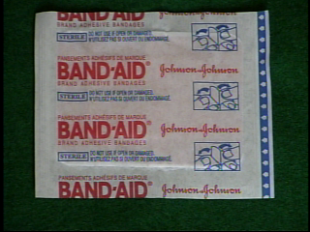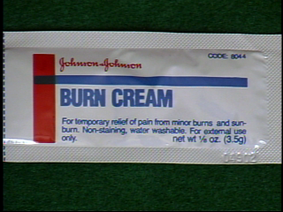

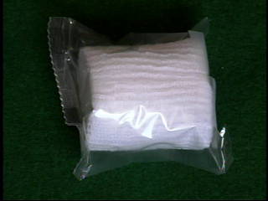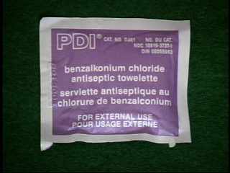
First Aid Serbian SOLT 1
Skill Enhancement Activities Module 5 Lesson 2

Activity 1 (continued)

Student C:

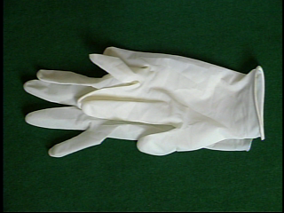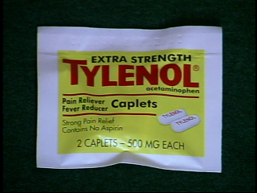

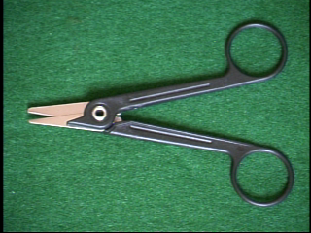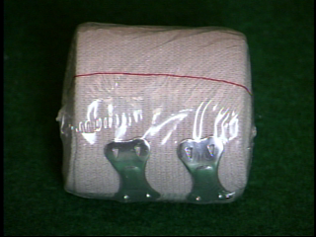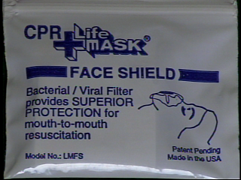

Activity 2
Your partner has left you a message on the answering machine about the supplies that she bought. Listen to the instructor and write down the items. Put the items under the right group written below.

Несесер Прва помоћ

First Aid Serbian SOLT 1
Skill Enhancement Activities Module 5 Lesson 2

Activity 3
You and your Yugoslav counterpart are preparing a training session for a Yugoslav group on how to stop bleeding. Look at the image and label it in Serbian. Compare your work with the rest of the class.

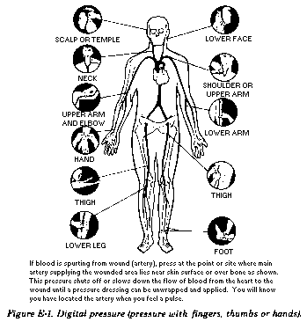

First Aid Serbian SOLT 1
Skill Enhancement Activities Module 5 Lesson 2

Activity 4
Read and role-play. The instructor will have the students in charge of the class prepare the necessary bandages and accessories for stopping bleeding and bring them to class, as well as many other objects related to medicine (the number of objects should equal the number of students in the class).
Show and name. The instructor will show each accessory to the class and review its name. Then the class will be divided in two groups Орлови – Eagles and Лавови – Lions.
The game proceeds as follows. A student from the Eagle group picks up an object, and any student from the Lion group gives its name. Then a student from the Lion group comes up to the table and picks up another object. Now any student from the Eagle group has to name it. The game continues until all objects have been named. The instructor keeps the score. The group who named the largest number of objects wins.

Activity 5
Read the following text and decide if the statements are true or false.
Сви људи у Југославији требају знати пружити прву помоћ. То је веома важно за возаче. Сваки возач у Југославији мора завршити курс прве помоћи. Када се деси несрећа, унесрећенима се пружа прва помоћ и зове се хитна помоћ. У колима хитне помоћи је обично дежурни лекар и медицински техничар.

T F

1. This text is about an accident. _____ _____

2. Every potential driver in the FRY should _____ _____
have the first aid course.

3. The emergency number should be called _____ _____
as soon as the accident happens.

4. There is usually only a medical technician and a _____ _____
driver in the emergency vehicle.

First Aid Serbian SOLT 1
Skill Enhancement Activities Module 5 Lesson 2

Activity 6
Listen to the instructor read the news about a traffic accident and answer the questions.

- Where did the accident happen?
- How many people were injured?
- How many people have died?
- Where were the injured people transferred too?

Activity 7
Your partner has just read some definitions and warnings written in Serbian but he/she doesn’t understand their meaning. He/she will ask you for help. Help your partner by giving him/her an explanation in English.

- Стезач је гумица дуга отприлике један метар и дебљине 3 мм.
- Упозорење! Стезач не сме да се држи дуже од два сата. После два сата мора се скинути.
- Стезач се не сме стављати на голу кожу.

First Aid Serbian SOLT 1
Homework Module 5 Lesson 2

Activity 1
What is needed for the treatment of the following health occurrences? Underline the right choice.

1. flu a. маказе
b. сируп
c. фластер

2. a bump a. лед
b. завој
c. пинцета

3. constipation a. крема за лице
b. стерилна газа
c. таблете против затвора

Activity 2
Listen to the following dialogue and mark if the statements are true or false.

T F

1. The dialogue takes place in a hospital. _____ _____

2. The customer needs the aspirin. _____ _____

3. The customer needs iodine. _____ _____

4. The total bill is 15 din. _____ _____

First Aid Serbian SOLT 1
Homework Module 5 Lesson 2

Activity 3
In the space provided write down in Serbian what personal hygiene or first aid items you will need in the following situations. Compare your answers with the rest of the class the next day.

You are camping out with your friends. You have cut your finger.
________________________________ ___________________________
________________________________ ___________________________
________________________________ ___________________________
________________________________ ___________________________

Activity 4
Below are different packages of the first aid and their description. Read each description and match it with the images. Then answer the questions.

Зидна апотека димензије (340x260x135 mm) намењена за производне погоне и јавне установе.
Метална ручна апотека (270x200x80 mm) намењена за мање радионице, градилишта и рад на терену.
Кутије прве помоћи за моторна возила свих категорија
Торбице прве помоћи намењене Цивилној заштити

- Where would you expect to find the first aid bags?
- Is it likely to find зидну апотеку in a Yugoslav home.
- What can you find in almost every motor vehicle in the FRY?

