SOLT Serbian Module 5 Lesson 3

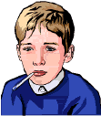

Medical Symptoms

Medical Symptoms Serbian SOLT 1
Objectives Module 5 Lesson 3

During this lesson, the students will learn about Medical Symptoms. Under this Terminal Learning Objective, the students will learn one task: describe symptoms. At the end of the lesson, the students will be able to:

- Describe symptoms. This task will include:

- Ask about personal comfort/discomfort
- Respond to personal comfort and discomfort
- Ask about one’s health and well being
- Respond to one’s health and well being
- Express concern and worry about the sickness
- Ask about fever, disease, operations and medical treatment
- Respond about fever, disease, operations and medical treatment
- Talk about the health problems and describe symptoms

Medical Symptoms Serbian SOLT 1
Introduction Module 5 Lesson 3

Tip of the day
When someone sneezes, one usually says Bless you! – the Serbian term is Наздравље!

Exercise 1
Your partner doesn’t feel very well today. Ask him/her what is wrong. He/she will give you an answer using some of the expressions given below. Reverse the roles.

Како се осећаш? Or Како си?
Нисам добро. Болестан/болесна сам.

Шта ти је? Шта те боли?

Боли ме зуб. Имам зубобољу. (toothache)
Боли ме глава. Имам главобољу. (headache)

Боле ме уши. Имам ушобољу. (earache)

Боли ме грло. Имам гушобољу. (sore throat)

Боли ме стомак. Имам пролив. (diarrhea)

Боле ме леђа. Имам болове у леђима.

(backache)

Кашљем и кијам.

(I cough and sneeze.)

Имам: чир у стомаку (ulcer)
прехладу (cold)
упалу мишића (muscle inflammation)
имам затвор (constipation)
астму (asthma)
грчеве (cramps)
грозницу (fever)
хемороиде (hemorrhoids)
реуму (rheumatism)
упалу крајника (tonsillitis)
укочен врат (stiff neck)
низак притисак (low blood pressure)
висок притисак (high blood pressure)
мучнину (nausea)

Medical Symptoms Serbian SOLT 1
Introduction Module 5 Lesson 3

Exercise 2
Milan doesn’t feel well today, so he has decided to visit a doctor. Choose the role of Milan or his doctor with your partner and read the dialogue below. After reading, answer the questions.

Код лекара

Лекар: Како се осећате данас?
Милан: Лоше. Прехладио сам се.
Лекар: Јесте ли мерили температуру?
Милан: Јесам. Немам високу температуру,
али ме боли грло и имам кијавицу. head cold
Лекар: Да ли имате нешто за прехладу?
Милан: Немам.
Лекар: Отворите уста и реците АААААА.
Милан: Ааааааа
Лекар: Изгледа да вам је грло упаљено. it looks
Милан: Надам се да немам упалу плућа. pneumonia
Лекар: Не брините. Немате упалу плућа.
Само малу прехладу. Пијте чај са медом и
узмите витамин C-е. vitamin
Милан: Хвала докторе.

    - Шта је Милану?
    - Да ли Милан има болове у стомаку?
    - Где Милан осећа болове.
    - Да ли Милан има упалу плућа?
    - Шта је лекар препоручио?

Medical Symptoms Serbian SOLT 1
Introduction Module 5 Lesson 3

Exercise 3
You are in the doctor’s office. The doctor (your partner) is asking you about your health, and you are responding by giving a description of your symptoms and expressing your concern about your condition. The doctor will recommend what you should do. Follow the example written below and refer to the vocabulary list for unfamiliar words or expressions.

Example: -Како се осећате?
-Не осећам се добро/осећам се лоше.
-Да ли вас нешто боли?
-Да, боли ме стомак и имам мучнину. Не могу ништа да једем.
Бојим се да/Плашим се да имам чир на стомаку.
-Послаћемо вас на рендген. (to go for an x-ray) За сада једите само
лагану храну и пијте доста течности.

симптоми забринутост препорука
(symptoms) (concern) (recommendation)

болови у стомаку депресија избегавати масну храну
грчеви чир на желуцу пити доста течности
висока температура дијабетис дружити се
болови у леђима срчани напад редовно вежбати
крварење из носа упала јетре ићи на рендген
жеђ упала бубрега извадити крв
болови у ногама упала мехура
болови у рукама тумор
мучнина
слаб вид
велики апетит
губитак апетита
вртоглавица
бити увек лоше воље
несаница

Medical Symptoms Serbian SOLT 1
Introduction Module 5 Lesson 3

Exercise 4
Look at the picture below, read the phrase, and change it in the following way: A) use different pronouns, B) change the statement into the negative form.

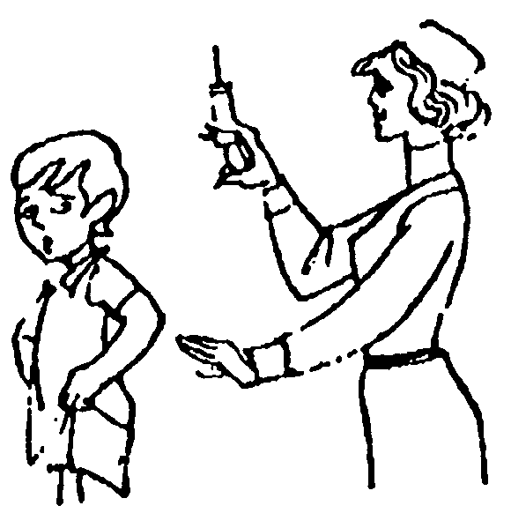

Јао! То ме боли! Ouch! It hurts!

Exercise 5
Read the joke below. Do you understand the meaning? Render it into English and compare your work with a partner.

Ваш кашаљ је данас много бољи.
Није чудо докторе. Вежбао сам целу недељу.

Medical Symptoms Serbian SOLT 1
Grammar Notes Module 5 Lesson 3

Verbs: чинити се (it seems), изгледати (it looks)

Sentences with чинити се and изгледати are among those which are structured similarly in English and Serbian. A few additional points, however, need to be made about the expressions чини ми се/изгледа ми followed by a да – clause. Look at the examples below.

Examples:

Чини ми се да је он добар инжењер. It seems to me that he is a good engineer.

Чини нам се да сте веома млади. It seems to us that you are very young.

Note that in this construction Serbian has no equivalent for English – it. The dative – to me and the 3rd person singular of the verb чинити се take care of the – it. Note also that the dative short form of the personal pronoun (ми, ти...) must immediately precede се, regardless of the order of the other words in the expression. The past tense looks as following:

Чинило ми се да је он добар инжењер. It seemed to me that he was a good
engineer.

The phrases with изгледати follow the same pattern and have the same meaning.

Изгледа ми да је она веома млада. It looks to me that she is very young.

(past) Изгледало ми је да је оне веома млада. It looked to me that she was very
young.

Exercise 1
How would you say it in Serbian?

- It seems to me that it is cold outside.
- It looks to me that you are not feeling well.
- It looked to her that the book was boring.
- It seemed to Milan that it was morning.

Medical Symptoms Serbian SOLT 1
Grammar Notes Module 5 Lesson 3

Constructions denoting illness and pain

The following sentences illustrate Serbian words that express illness and pain.

1. Да ли Милан ради данас? Is Milan at work today?
Не, болестан је. No, he is sick.

2. Када се разболео? When did he get sick?
Изгледа пре два дана. It looks like two days ago.

3. Шта му је? What’s wrong?
Какву болест има? What illness does he have?
Каже да има главобољу и да не спава. He says that he has a
headache and that he cannot
sleep.

4. Да ли мислиш да он има озбиљне проблеме? Do you think that he has
serious problems?
Највероватније. Каже да осећа болове у желуцу. Most probably. He says that
he feels pain in his stomach.

Note the following words. The common element is здрав.
Adjectives здрав, здрава, здраво – healthy
Noun здравље – health
Verb оздравити – to get healthy, to get well, to recover

Exercise 2
Work with a partner. Pretend you are sick. Mimic your symptoms. Your partner
should guess what kind of illness you have. Reverse the roles.

Medical Symptoms Serbian SOLT 1
Vocabulary Module 5 Lesson 3

астма, е | asthma
бојати се | to be scared of
болест, и | sickness, illness
болестан, а, о | sick
боловати (oд) | to suffer from
висок притисак | high blood pressure
витамин, и | vitamin, s
вртоглавица, е | dizziness
гипс, гипсови | cast
главобоља, е | headache
гојазност | obesity
грозница, е | fever
грч, грчеви | cramp
гушобоља, е | sore throat
дрхтавица, е | chill, s
забринутост | concern
здрав, а, о | healthy
здравље | health
зубобоља, е | toothache
изгледати | to look
ишчашен, а, о (m, f, n) | dislocated
кашљати | to cough
кијавица, е | head cold
кијати | to sneeze
клекнути | to kneel
мућкати (impf.) промућкати (pf.) | to shake
мучнина, е | nausea
Наздравље! | Bless you!
неухрањеност | under- nourishment
низак притисак | low blood pressure
оболети | to get sick
оздравити | to get well
онесвестити се | to faint
плашити се | to be scared of
потапати (impf.) потопити (pf.) | to soak
препорука, е | recommendation
прехлада, е | cold
прехладити се | to get cold
пролив, и | diarrhea
разболети се | to get sick

Medical Symptoms Serbian SOLT 1
Vocabulary Module 5 Lesson 3

рендген | x-rays
реума, е | rheumatism
рецепт, и (лекарски) | prescription, s
свраб | rash, s
симптом, и | symptom
срчани напад (инфаркт) | heart attack
тумор, и | tumor
ултразвук, ци | ultrasound
упала, e | inflammation
упала плућа | pneumonia
ушобоља, е | earache
чинити се | to seem
чир, чиреви | ulcer

Medical Symptoms Serbian SOLT 1
Culture Notes Module 5 Lesson 3

Кашаљ (cough)
Did you know that a cough begins when an irritant reaches one of the cough receptors in your nose, throat or chest? The receptor sends a message to the cough center in your brain, signaling your body to cough. After you inhale, your epiglottis and vocal cords close tightly, trapping air within your lungs. Your abdominal and chest muscles contract forcefully, pushing against your diaphragm. Finally, your vocal cords and epiglottis open suddenly, allowing trapped air to explode outward.

Medical Symptoms Serbian SOLT 1
Application Activities Module 5 Lesson 3

Activity 1
Look at the cartoons below. Take turns describing the symptoms illustrated. Your partner will have to guess which symptom you are describing. He/she will point to the image. If she/he is right, please say: тачно or if he/she did not guess right say: нетачно and point to the right picture. The instructor will help you with the descriptions.

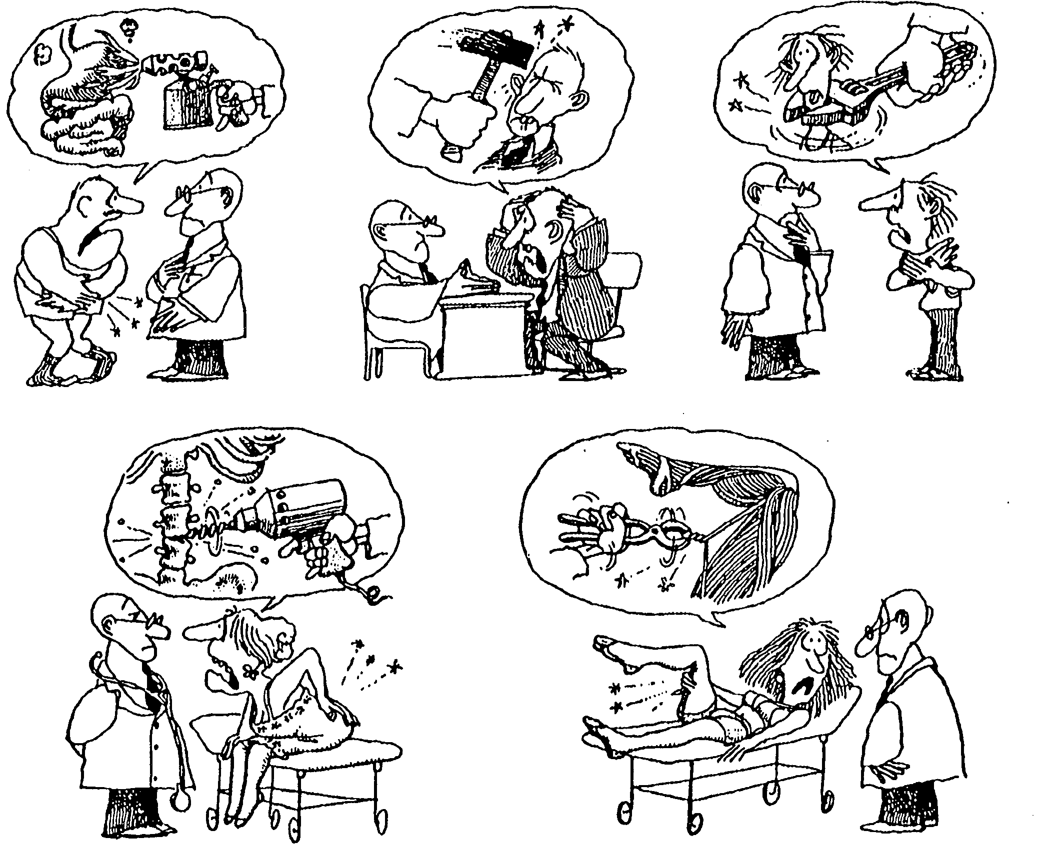

Medical Symptoms Serbian SOLT 1
Application Activities Module 5 Lesson 3

Activity 2
Play the role of a doctor. Your partner is a patient seeking your help. Ask him/her about symptoms that he/she has and give the advice. Follow the example given below:

Example: висока температура, грло, кијавица – таблете за прехладу

- Добар дан. Шта вам је?
- Имам температуру 39°, боли ме грло и имам кијавицу.
- Дајте да погледам. Мораћете да узимате таблете за прехладу.

1. стомак, мучнина - рендген
2. главобоља, умор, депресија – таблете против депресије (за смирење)
3. нога, рука – редовно вежбати
4. висока температура, слаб апетит, главобоља – таблете за упалу грла

Activity 3
Many famous people had died because of some illness that they had. Their names are given below together with the date of their birth, the date of their death and the name of the illness from which they died. Work with a partner. Ask him/her questions in Serbian about one person of your choice. Your partner will give you the answer. Reverse the roles.

Questions: When and where was … born?
When and where did … die?
From which illness did die? Од какве болести (од чега) је умро?
Умро је/умрла је од ....
How old was …?

Волфганг Амадеус Моцарт Франз Кафка
1756 Салзбург 1883 Праг
1791 Беч 1924 Кирлинг
болест: непозната болест: туберкулоза

Рок Хадсон Франз Шуберт
1925 Илиноис 1797 Беч
1985 Калифорнија 1828 Беч
болест: сида (AIDS) болест: тифус

Medical Symptoms Serbian SOLT 1
Application Activities Module 5 Lesson 3

Activity 4
Scan the text written below in the Roman alphabet and decide if the statements are true or false.
Od Drugog svetskog rata velike epidemije tifusa su registrovane većinom u Africi i to u Etiopiji, Ruandi i Burundiju. U Etiopiji, broj ljudi umrlih od tifusa se kretao između 7000 i 17000. 1996. godine u Burundiju je registrovano 3500 slučajeva tifusa, a 1997. taj broj je porastao na 20,000. Simptomi tifusa su najčešće glavobolja, groznica, visoka temperatura, kašalj i bolovi u mišićima. Peti ili šesti dan se obično pojave tamne fleke. One se rasprostiru po celom telu osim po licu, dlanovima i stopalu.

T F

1. This text is about the tuberculosis disease. _____ _____

2. This disease is registered mainly in Africa. _____ _____

3. The biggest number of people who had died _____ _____
from this disease was registered in Ethiopia.

4. One of the symptoms of this disease are the _____ _____
dark spots all over the body and fever.

5. The dark spots don’t appear on the face, palms _____ _____
or soles.

Activity 5
Radmila is in a doctor’s office. Listen to her conversation with the doctor and answer the questions.

- Шта боли Радмилу?
- Да ли се повредила?
- Шта каже лекар?
- Шта препоручује лекар?

Medical Symptoms Serbian SOLT 1
Application Activities Module 5 Lesson 3

Activity 6
Brainstorming. The class will be divided in two groups. The main question that needs to be answered is: In what physical condition is an Army recruit after a week of basic training, assuming the worst conditions, questionable food, and a merciless drill sergeant?
Each group should give one symptom at the time. The instructor will write the symptoms on the board. The group that comes up with the most symptoms is the winner.

Activity 7
For this activity, we will assume that everyone has some kind of health problem. Walk around the classroom and interview your classmates. Find out what health condition they are in, how they feel today, do they have any pain, and when have they ever been seriously ill, etc. Choose one of the classmates and give a report about him/her in front of the class.

Питања

Како се осећаш данас?
Да ли имаш болове? Где?
Од када имаш болове?
Да ли си ишао код лекара?
Да ли си икада био/била озбиљно болестан/болесна?
Од чега си боловао/боловала? (to suffer from)

________________________________________________________________________________________________________________________________________________________________________________________________________________________________________________________________________________________________________________________________________________________________________________________________________________________________________________________________________________________________________________________________________________________________________________________________________________________________________________________________________________________________________________________________________________________________________________________________________________________

Medical Symptoms Serbian SOLT 1
Skill Enhancement Activities Module 5 Lesson 3

Activity 1
Listen to the instructor read some sentences in which people say what is wrong with them and for how long they have felt unwell. Fill in the necessary information in the table below.

Name | What’s wrong? | How long
Милан
Рада
Светлана
Мира
Стефан

Activity 2
Match the statements or questions in the right column with those in the left column.

1. Већ 7 дана. | А. Шта је било са лекаром Симићем?
2. Не, али се не осећам добро. | Б. Од када имаш болове?
3. Он мисли да она има упалу грла. | Ц. Веома низак.
4. Колико је остала у болници? | Д. Да ли ти је досадно?
5. Умро је прошле године. | Е. Шта ти је?
6. Какав ти је притисак? | Ф. Шта је рекао лекар?
7. Боли ме зуб. | Г. Само три дана.

Activity 3
You are in the FRY and don’t feel well today. You have pain in the left arm and in your neck. Read the ad of a Belgrade clinic and figure out if the doctors there could help you with your health problem.

Medical Symptoms Serbian SOLT 1
Skill Enhancement Activities Module 5 Lesson 3

Activity 3 (continued)
Klinika Novi grad

Beograd

Klinika vam pruža sledeće vrste usluga:
- kardiološki pregled sa EKG nalazom,
- stres test
- laboratorijska analiza krvi
- merenje krvnog pritiska
- ultrazvučni pregled
- dečja kardiologija
- priprema za operaciju,
- kontrola posle operacije

Activity 4
If your answer was “yes” in the previous activity, underline the element that makes you answer that way. Now read the ad again and imagine that you are the representative of the clinic. Inform the patient (your partner) what kind of services does the clinic provide.

Activity 5
You drove your wife to a Yugoslav doctor in Belgrade. She has problems with breathing. You are standing in front of the door and reading a sign. Is this the right door? If not, what type of clinic is this?

Privatna ginekološka
Ordinacija

Abortusi
Porođaji
Lečenje steriliteta

Medical Symptoms Serbian SOLT 1
Skill Enhancement Activities Module 5 Lesson 3

Activity 6
You are the doctor. You just came into your office. Two of your patients have called and left messages. Listen carefully to what they say, and write down in English as much information as you can. Compare your work with a partner.
________________________________________________________________________________________________________________________________________________________________________________________________________________________

Activity 7
How would you react to these phone calls? Phone your patients (your partner) and find out about their condition now. Give them advice as to what to do. The instructor will monitor your activity.

Activity 8
What would you advise your friend to do if he/she had:

1. Fever
2. Sore throat
3. Cough
4. Insomnia
5. Nausea

Activity 9
Read the text and fill in the missing parts in the statements below.

У породици Радуловић обољења срца су веома честа. Многи чланови су умрли од срца веома млади. Деда господина Радуловића је умро са 50 година од срчаног удара. Отац господина Радуловића је умро са 48 година, такође од срца. Господин Радуловић и његова два брата су забринути за здравље. Зато иду на лекарске прегледе сваке године.

- One illness that is common in the Radulovic’s family is _________________.
- Mister Radulovic’s grandfather died at age 50 from __________________.
- His father died at age _________________.
- Mister Radulovic and his ______________ are concerned about their health.
- They do a physical exam ______________________.

Medical Symptoms Serbian SOLT 1
Homework Module 5 Lesson 3

Activity 1
Listen to what Maria says about her recent health problem and complete the sentences.

- Maria was suffering from_____________.
- The doctor advised her to do some __________________.
- Maria thinks that the doctor __________________.

Activity 2
Imagine that your child attends a school in the FRY. Complete the following absence excuse note to his teacher. Compare your note with the rest of the class the next day.

Поштовани господине Петровић,

Мој син, Синиша Костић, не може да __________ данас у школу. Он се не ________ добро, има високу _______ и осећа _________ у стомаку. Данас идемо код ________ да га прегледа. Хвала много на разумевању.

Your signature

Activity 3
Read the letter below and answer the questions?

Имам папагаја старог годину дана. У задње време доста кија и има слаб апетит. Да ли је у питању прехлада или промена годишњег доба?

- To whom do you think this question is addressed?
- Who is the patient?
- What is his/her problem?

Medical Symptoms Serbian SOLT 1
Homework Module 5 Lesson 3

Activity 4
Write down in a few short sentences about the current health condition of your family members. Do some of them often suffer from a cold or heavy cough, etc. The instructor will check your work the next day.

________________________________________________________________________________________________________________________________________________________________________________________________________________________________________________________________________________________________________________________________________________________________________________________________________________________________________________________________________________________________________________________________________________________________________________________________________________________________________________________________________________________________________________________________________________

